12/8/2024 SAPHNA Safeguarding the Safeguarders

Discussion in regard to the recording of session, decided that we will share links and themes that emerge from the group.

Acknowledgement of the challenges and social unrest that is currently occurring, Kenny highlighted PREVENT, introduced Deborah to the group, welcome.

Discussed Thresholds/Complexity of practice/Think Family/terms such as Toxic Trio-troubled families-ACE’s/ student experience/Pathfinders-please email Kenny or Deborah if you would link to link in /GP’s and charging for cyp health information-don’t forget ICB has named GP for safeguarding/ letter being drafted re over 16’s with HCP and no health resource allocated and access to education

All present asked to consider linking with ICB Chief Nurse and or Director of Nursing -if unsure who this is please email Kenny.gibson@nhs.net or Deborah.perriment2@nhs.net
NHS Safeguarding keeps you updated on safeguarding & trauma informed practice via our free Agile NHS Safeguarding Guide (L1) and our NHS Safeguarding Future NHS learning platform (L2+) if you are more professionally curious; our Safeguarding Webinars & Learning Together Weeks - NHS Safeguarding Workspace - FutureNHS Collaboration Platform (L3+) and our L4/5 ICB Level 4 Leadership recordings - NHS Safeguarding Workspace - FutureNHS Collaboration Platform
NHS England » NHS England Safeguarding app
Why language matters: how ‘toxic trio’ is unhelpful and inaccurate | NSPCC Learning
Ecomaps: Guide For Social Workers, Examples and Templates - Free Social Work Tools and Resources: SocialWorkersToolbox.com
DfE non statutory information sharing advice for practitioners providing safeguarding services for children, young people,parents and carers (publishing.service.gov.uk)

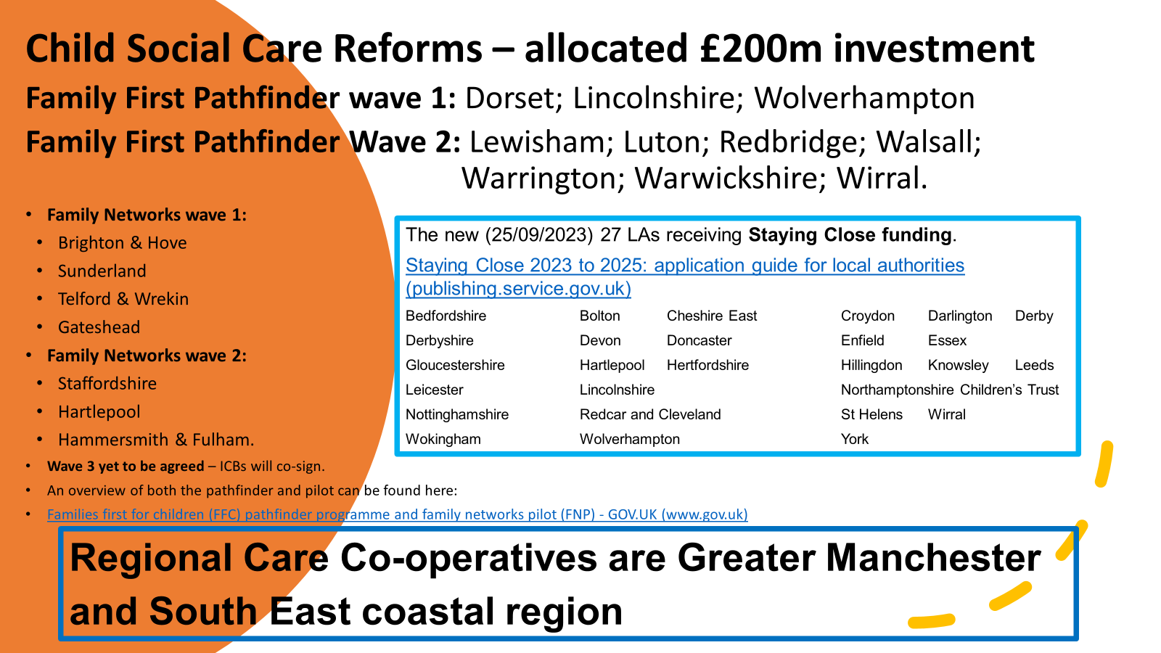

Home - QR Code Resources - MAAPP
NHS England » NHS England Safeguarding app
Community-Mapping-Toolkit-3.pdf (elft.nhs.uk)
Please share any examples Case Studies | SAPHNA – School And Public Health Nurses Association
Messages from Kenny
- School nurses must never feel alone with safeguarding – they should connect with the full range of health care practitioners who might have a touch-point with school-aged children, including GP practice, mental health, SEND and sexual health colleagues. We all have our part to play and we must all make every contact count.
- School nurses should consider co-signing any safeguarding referrals with the named safeguarding GP.
- School nurses should be inspired to rebalance the belief that they are the only practitioner who can attend a child protection meeting.
- We need to inspire everyone to think family and think household since not every child lives in a family.
- School nurses need to understand which peer advocacy services are locally available to visit (might the integrated care partnership have a list?) or national available services by www.
- School nurses need to be at the table of Working Together Pathfinders and Child Social Care Regional Care Co-operatives.
- School Nurses should offer shadowing to ICB CNO and DoNs.

Julie Critcher 15th August 2024

