Creating an Effective Competition Poster

Top Tips!

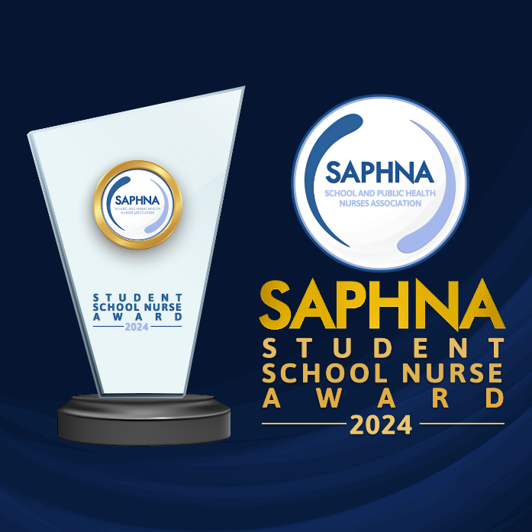
Welcome to the SAPHNA Student Award 2024! We're excited to see the innovative ideas and practices you'll be presenting through your posters. To assist you in creating an impactful and visually appealing poster, we've compiled a set of top tips covering both appearance and content. Ensuring clarity, using appropriate font sizes, incorporating visual elements, and maintaining consistency in layout are crucial aspects of creating an effective academic poster. Furthermore, clearly labelling sections with headings and subheadings, along with providing suggestions for content under each, will guide viewers through your poster seamlessly. Remember, balance and engagement are key; distributing content evenly and encouraging viewer engagement through visuals and concise text will enhance the overall effectiveness of your presentation.

As you embark on creating your poster, we encourage you to explore examples of posters and templates available online, which can provide inspiration and guidance. We look forward to seeing your innovative ideas come to life through your posters!

Appearance

Clarity:
- Tip: Ensure that your poster is clear and easy to read from a distance. Use legible fonts e.g. Arial and avoid overcrowding with information.
- Why it matters: Clarity enhances the viewer's understanding of your innovation and makes it more accessible.
Font Size:
- Tip: Use a readable font size for all text. 32pt is easily readable up to 6 feet away on an average size 36” x 48” poster. We suggest using between 28pt and 40pt for best viewing. Ensure headings and subheadings are appropriately sized for increased emphasis.
- Why it matters: Legible text is essential for effective communication, allowing viewers to grasp key information quickly.
Visual Appeal:
- Tip: Incorporate graphics, charts and images to enhance the visual appeal of your poster.
- Why it matters: A visually engaging poster is more likely to attract and hold the viewer's interest and convey information effectively.

Colour Scheme:
- Tip: Choose a cohesive colour scheme that complements your content. Use colours purposefully to highlight key points.
- Why it matters: A well-thought-out colour scheme enhances visual appeal and reinforces the poster's overall design.

Content

Headings and Subheadings:
- Tip: Clearly label sections with headings and subheadings, see suggestions on the template provided. Use them to guide the viewer through your poster and highlight key information.
- Why it matters: Headings and subheadings provide structure and help viewers quickly locate and understand the content within each section. Here are some suggestions, and what you may like to present under each:
  - Abstract – summarise your innovation in practice, its uniqueness, intended impact on health outcomes, and how it addresses health inequalities
  - Introduction - Briefly introduce the context and need for the innovation. Clearly state the goals and objectives of the service development.
  - Innovation in practice - Describe the uniqueness and originality of the idea.
    - Leadership: Provide evidence of the initiative being school nurse-led.
    - Partnership: Showcase the importance of collaboration with partners for sustainable changes.
  - High Impact Areas - Highlight the specific high-impact areas the innovation focuses on (e.g., mental health, immunisation, sexual health, etc.).
  - Successful practice - Explain the innovative aspects of the idea. Emphasise the use of evidence to inform the development of the innovation.
    - Value: Demonstrate the intended impact on health outcomes and reducing health inequalities.
    - Measurable: Describe the evaluation methodology for assessing the initiative's impact.
    - Transferable: Discuss how the ideas can be shared or adapted for use in other school nursing services.
  - Results and Evaluation –
    - Outcomes: Present what are or will be the measurable outcomes and improvements you have, or you hope to achieve.
    - Lessons Learned: Discuss any challenges faced or you predict, and lessons learned during the planning or implementation.
  - Conclusions - Summarise the key points of the innovation.
    - Future Directions: Suggest potential future developments or expansions.
  - References

Consistency:
- Tip: Maintain a consistent and organised layout throughout your poster. Organise content logically, with a clear flow from one section to another.
- Why it matters: Consistency promotes a professional appearance and helps viewers navigate your poster easily.
Balance:
- Tip: Distribute text and visuals evenly for a balanced composition. Avoid overcrowding one area while leaving another empty.
- Why it matters: Balanced layouts contribute to a harmonious and professional appearance, preventing visual overload.
Engagement:
- Tip: Encourage viewer engagement through thought-provoking visuals and concise text. Use bullet points and short sentences to convey information efficiently.
- Why it matters: Engaged viewers are more likely to remember and appreciate the details of your innovation.

