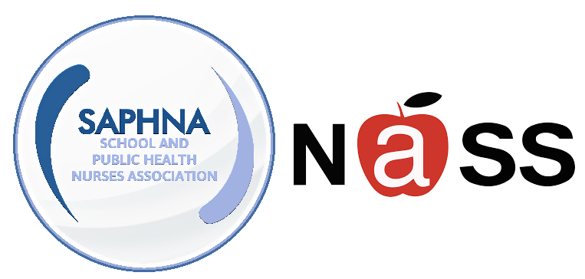
‘SEE ME, HEAR ME, SUPPORT ME: STAYING HAPPY AND HEALTHY’

ONLINE CONFERENCE, MARCH 1ST 2023 FOR NURSES WORKING IN EDUCATIONAL SETTINGS WITH CHILDREN AND YOUNG PEOPLE WITH SPECIAL EDUCATIONAL NEEDS AND DISABILITIES (SEND)

Wednesday 1st March 2023
9.30 a.m. – 3.30 p.m. Via MS Teams

In response to highlighted need from our nursing colleagues working with school aged children with special educational needs and/or disabilities (SEND), the National Association of Independent Schools and Non-Maintained Special Schools (NASS) and the School and Public Health Nurses Association (SAPHNA), are delighted to present the first known dedicated conference for this workforce.

This is aimed at all nurses, including community children’s nurses, specialist school nurses, school nurses (independent and state) and relevant others.

Deadline for receipt of cancellations: 17th February 2023
Deadline for receipt of bookings: 21st February 2023

Booking Terms & Conditions
- Prices:
  - NASS and SAPHNA members £100
  - Non-members £120
- The delegate fees shown are per person and include access to recordings of all sessions.
- For non-card payments, our invoice terms are strictly payment within 30 days of the date of the invoice.
- Bookings are non-transferable between other NASS and SPAHNA events, but delegate substitutions will be accepted.

Cancellation Terms & Conditions.
50% of delegate fees will be refunded for cancellations received by 17th February 2023.
After this date no fees are refundable for cancellation or non-attendance.
For bookings through NASS all cancellations must be confirmed in writing by email to krippon@nasschools.org.uk. For bookings through SAPHNA all cancellations must be confirmed in writing by email to info@saphna.co
We reserve the right to cancel an event due to insufficient numbers.
In the unlikely event that NASS/SAPHNA have to cancel an event, our liability in the event of cancellation is limited to a full refund of the event fee only.

