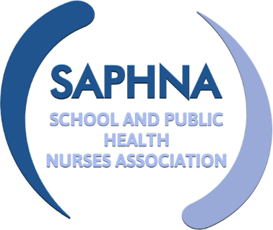
SAPHNA SPECIAL INTEREST GROUP

Accident and Emergency liaison pathways

Held via MS Teams 25th May 2022

MEETING MINUTES
Attendees: | Gemma Clark  Ann Podsiadly  Julie Critcher  Diane Irvine  Fiona McKenna  Jean Ravenna  Anne Murphy | Technical Manager, SAPHNA  Professional Lead SN, Sussex  Professional Lead SN, Canterbury  SN, Girvan Scotland  Clinical Lead SN, Medway  Specialist Community Public Health Nurse, Kent  ?
Apologies: | Sharon White  Sallyann Sutton  Dr Peter Green  Lisa Worth  Rebecca Ellis  Maggie Clarke  Susanna Scales  Christine Beer  Alison Morton  Mark Lippett  Tryphine Molineux | CEO, SAPHNA  Professional Lead 0-19, Walsall  Designated Doctor and Consultant for Child Safeguarding, Wandsworth  Paediatric liaison nurse, Walsall  ?  Assistant Director Universal Services, Compass  ?  ?  ?  ?  Professional Lead SN, Walsall

Item | Discussion | Action | Deadline
Welcome and Introductions | Chaired by Ann Podsiadly  Introductions made by all in attendance
Terms of Reference | Circulated before meeting – all agreed to TOR
Current issues / best Practice  Open Discussion | Open discussion:  Picked up from Feb’s meeting  - Volume of a/e referrals to SN’s  - Fiona McKenna - Spoke of referrals within her team – would like a national support board  - AP – spoke with SW about where this group is going. Looking at principals and action – what we feel SN can deliver on when it comes to A/E referrals – If we can get guiding principles / wider sharing in first instance  - Anne Murphy – 2 district general hospitals – done some work with A/E dept re sharing info, assessments, child protection etc.  Would all like to remove paper, receive all electronically, although not without difficulties as most come in bulk so all need to be opened, separated, and saved  AGREE A CRITERIA
To share common issues and best practice
What next?
Date and time of next meeting | Wednesday 27th July 9.30am-11am – CANCELLED  Next meeting 7th September 2022 09:30 – 11am | Gem to send Teams invite | Done

