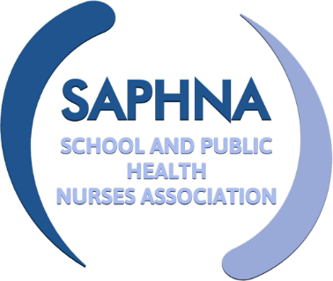
SAPHNA SPECIAL INTEREST GROUP

Nurses working with SEND children and young people

Meeting Held 20th January 2022

Attendees: | Elaine Davies  Rita Jenner  Kath Lancaster  Nicola Tucker  Vicki Coatsworth  Angie Fudge  Alison Payne  Dave Owen
Apologies: | Sharon White  Emma Weston

Item | Discussion | Action | Deadline
Welcome and Introductions | The group introduced themselves and shared their current job role
The Lancaster Model SEND Pilot. Kath Lancaster, Independent Consultant | The Lancaster Model provides a validated, systematic approach to assess the needs of individuals and populations, identifying children and young people earlier who would most likely be 'under the radar'. The model provides an online Health Needs assessment Tool enabling children and young people receive a health and development review at set life changes and population data to strengthen preventative, public health practice delivery. For more information see https://www.thelancastermodel.co.uk/how-tlm-works/  KL explained that It is recognised that C&YP with SEND require a supported or adapted approach depending on their level of need. KL has began working with providers in Kent to research this gap. KL is completing a 2-year pilot/action plan with specialist input from Kent. KL is currently planning the first stage of the process of change; scoping schools that would like to be involved. This will commence March/April for three months.  This will be followed by concurrent pilots to implement three levels of the HNA (level 1 C&YP needing support to complete online HNA. Level 2. C&YP needing a simplified HNA tool. Level 3 C&YP needing a completely different approach to complete an HNA.) Pilot A. Implement the original online tool with additional help and support for pupils from education staff. Pilot B. Develop a simplified/amended online version in partnership with CYP/families and staff 3. Pilot C Test the amended version with level 2 C&YP. Pilot D work to develop a needs led different approach for level 3 C&YP. This will be followed by looking at the roles of the workforce, i.e. When the public health data comes through who will do what?  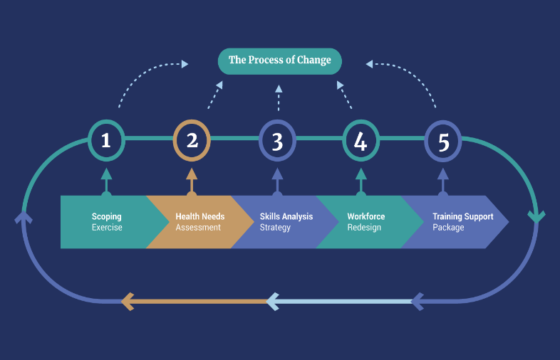  The Lancaster Model Process of Change  KL agreed to return to the group to feedback how the work is developing June/July this year.
Education Health Care Plans and Annual Reviews. Rita Jenner, Deputy Designated Clinical Officer – SEND. SAPHNA Committee | RJ explained that it is a statutory duty for professionals to provide advice if they are working with the child/family.  The ‘golden thread’ running through plans is the voice of the child. There is a 6-week time frame for advice to be collated, child and parents are consulted and a draft EHCP is put together.  Advice must be written about the child’s needs not the service needs. Services need to be clear and honest about outcomes that are realistic achievable and available. E.g. In 6 months’, time Jonny will be supported to take his medicines via tablet form (not liquid).  It is important to simplify medical terms so that the wording is easy to understand. Vague wording such as ‘regular’ and ‘opportunities’ should not be used.  Annual reviews – the ownership of this lies with the school. Co-production with the child and family is crucial.  Four weeks prior to the meeting the school asks for reports ad gathers information. Professionals are invited but are often not able to attend. Information/reports should be sent if you are working with a C/YP.
SAPHNA Guidance Long Covid in Children and young people | https://saphna.co/news/long-covid-in-children-and-young-people/
Requests for agenda items | Transition/Preparation for Adulthood including LD Annual Health Checks
Next meeting | Tuesday 22nd March 2-3pm

