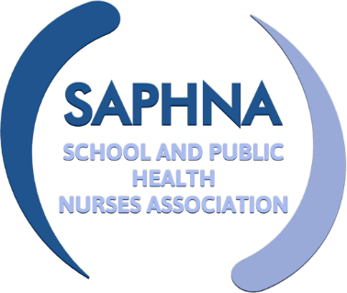
SAPHNA SPECIAL INTEREST GROUP

Nurses working with SEND children and young people

Meeting Held 2nd December 2021

Attendees: | Elaine Davies  Rita Jenner  Lucy Oliphant  Claire Warriner  Laura Gibney  Nicola Tucker  Adebisi Akinwunmi  Helen Shepherd
Apologies: | Sharon White

Item | Discussion | Action | Deadline
Welcome and Introductions | The group introduced themselves and shared their current job role
Tracheostomy care | Discussion regarding training of education staff. This is very time consuming and is compounded when trained staff leave, move classes or are absent on sick leave; meaning new staff need to be trained. In some area’s families use the child’s continuing care package to provide a trained 1:1 person for the child in school. Training then is only required for a second and third person to support for breaks and in an emergency. This works very well in the Liverpool area. Unfortunately, this approach is not accepted by all schools for a variety of reasons e.g. will only allow school employed staff to work with the child  In Suffolk they do something totally different. They have a locality team led by two nurses that's employed by education. They train special learning assistants and care assistants. The assistants come on the transport with the child, bring them into school and then stay with them in the school. In Calderdale they combine the school money and the continuing care monies to enable a joint teaching assistant and health care needs post.  Discussion regarding transport to school for these children -This appears to be very difficult in some areas. The pandemic and the guidance on AGP’s has made this especially difficult. | Explore if there is any further guidance.  Put the topic as a red flag for further thought.
Blended diet | Discussion re the British Dietetic Association Blended Diet new practice toolkit and using gastrojejunostomy tubes with blended diet. ED discussed that she is looking at this with dietetics very soon in her area to update their policy. The group discussed that most areas had risk assessments but the new toolkit from the BDA had not yet been fully implemented. Competency sign off for education staff is taking place in most areas now. | ED agreed to share her service risk assessment and policy for blended diet once this has been updated. | March 2022
General discussions | - Capturing the thoughts/feelings/worries of non-verbal children. Evidencing harm. Work with education staff. If we cannot communicate at all with a child, then our views would be based on professional assumption.  - Delivering the healthy child programme in special schools – HNA key staged contacts. NT from Liverpool is looking to develop this for special school nursing. ED updated re the Lancaster Model.  - Covid vaccination – discussed that many of the specials school nurses had wanted to help with the programme but the lengthy training was prohibitive and not possible within current resource. Uptake of the vaccine had been thought to be low and may have been improved if nurses who knew the families to have conversations had been involved.  - Variation of how the service is delivered in different regions – In some areas there is no special school nursing service. Training is available to education staff from the CCN team. The group felt national guidance was very much needed for special school nursing. The possibility and benefits of a vision for nurses working with C&YP with SEND in schools was touched on. | Kath Lancaster to be asked to speak at the next meeting re the Lancaster model for SEND  To be red flagged for further discussion next year.
Case Studies | ED discussed a case study on converting children from liquid medication to tablets. See link for further information northernpaediatrics kidzmed programme  ED discussed a case study supporting a child with SEND through anxiety prior to surgery.  Example of Special School Nursing Storyboard and case studies – here
Requests for agenda items | - The group requested further information and update from Kath Lancaster on the Lancaster model SEND pilot at the next meeting.  - The group requested further information on EHCP’s and annual reviews.  - Co-production, YP participation, ‘You said, we did’.  - Liberty Protection Standards  - Key working for children and young people with both a learning disability and a mental health need.  - Transition | - Kath Lancaster to be asked to present initial finding of the SEND pilot at next meeting.  - Rita Jenner to present re EHCP’s  - Ask Jo Gilliland (jo@ntpcf.co.uk) – National Network of Parent Carer Forum Steering group member for North East & Cumbria to speak to the group about the importance of co-production with families.
Next meeting | Thursday 20th January 2-3pm

