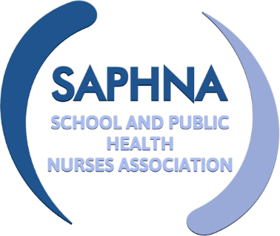
SAPHNA SPECIAL INTEREST GROUP

Nurses working with SEND children and young people

Meeting Held 30th September 2021

Attendees: | Elaine Davies  Rita Jenner  Claire Warriner  Rebecca Boxall  Vicky Coatsworth  Gemma Clark (minutes)
Apologies: | Sharon White  Kath Lancaster  Nicola Tucker

Item | Discussion | Action | Deadline
Welcome and Introductions | Elaine chaired the session  All in attendance introduced themselves and gave brief summaries of their backgrounds and current roles
Terms of reference | All viewed and agreed these.
Wants and needs from group | General consensus from the group was that there is a lack of resources and peer support working in this field and that this group is beneficial.  The group discussed the diversity of their roles and how they are working very differently to each other depending on the area of the country they are working in. Some nurses are working very much to a medical model and others are working in mainstream teams with a focus on improving public health support for C&YP with SEND.  Resources would be welcomed to help C&YP with Imms, continence, managing periods, self-hygiene etc. Elaine discussed that often these need to be bespoke as different schools use different communication tools. Easy Read resources are also useful. Some useful links are →  The sharing of training packages for education staff would be helpful to those providing special school nursing services.  Information and resources for C&YP with disabilities and families about weight/healthy eating would be welcomed. See https://www.nhs.uk/change4life There does not appear to be anything specific for children with disabilities. | A survey will be sent out with the minutes to ask for topics that the group would like to discuss further. The meetings can then focus on pertinent topics to the group.  See Mencap for pdf resource and animated video and some resources about gender identity, gender expression, sexuality and celebrating you being you: https://www.mencap.org.uk/advice-and-support/relationships-and-sex/relationships-and-sex-resources  See NSPCC Love Life: resources for young people with learning disabilities https://learning.nspcc.org.uk/research-resources/schools/love-life  See Gov.Uk for easy read resources about Covid vaccination:  https://www.gov.uk/government/publications/covid-19-vaccination-easy-read-resources-for-children-and-young-people  Easy read resources and social stories from bladder and bowel UK:  https://www.bbuk.org.uk/children-young-people/children-resources/  Training packages can be shared. ED can share on request including staff induction training, gastrostomy and blended diet. Suggested outline of training for PMLD School is here.
Attendees’ emails |  | Gemma to share emails to Elaine and Rita
General discussions | ED discussed that Independent Consultant Kath Lancaster is piloting a new Health Needs Assessment/The Lancaster Model for children with SEND with health services in Kent. Information and outcomes should be available from January 2022. Kath plans to join future meetings of this group and will bring updates.  ED discussed the benefits of joining SAPHNA. Not a member of SAPHNA yet? Please take a look and see how much more we can offer you! https://saphna.co/get-involved/join-saphna/  RJ talked about Education Healthcare plans and recommended the website council for disabled children  https://councilfordisabledchildren.org.uk/ | Plan for one session to be on EHCP’s and planning for inspections.
Next meeting | 2nd December 2021 14:30 till 15:30. Agenda to follow.

