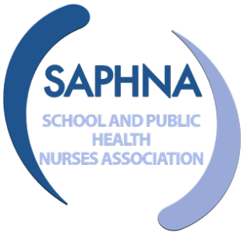
Health and Wellbeing Digital Offer: Research
Priorities for Children and Young People’s

Seeking Children and Young People Views of the Digital Offer for Health and Wellbeing and Wellbeing

What is the Research priorities for Health and Wellbeing Digital Offer Project?

A Patient and Public Involvement (PPI) project has been commissioned by PHE Maternity and Early Years Directorate to engage a representative sample of children and young people to inform the development of a range of questions to be used for research into the digital service offer from School Nursing.

As part of this project, we are seeking the support of professionals including School Nurses, Youth Worker, education, or community workers to help gain the views & ideas of children and young people that you work with.

What will this involve?

We would like you to facilitate a short activity session to gain the views and ideas of children and young people aged between 10 years (in year 6) and 25 years old. We anticipate that the activity sessions to take place in late autumn term 2021/early spring term 2022. Each session should last no longer that 60 minutes. The feedback from the sessions can be scanned and emailed to the project lead.

The facilitators will need to gain consent of the child or young person to take part in the activity. An information leaflet and consent form will be provided. Information will be managed in accordance with the GDPR arrangements. Facilitators will need to provide the SAPHNA project lead with anonymous demographic information including the number of participants, ethnic backgrounds and their ages. This information is collected so that we can understand whether the children and young people who have taken part of representative of the age group.

How will facilitators be supported

Each facilitator will be provided with a brief for the session and with the activities to stimulate conversations with children and young people. The facilitators then work face to face with the children and young people. Facilitators will be briefed and supported by virtual video conferencing sessions.

What questions will be asked during the activity sessions?

- What do you think might the benefits or advantages of using digital technology for help or information about Health and Wellbeing and well-being?
- What do you think might problems or disadvantages of using digital technology for help or information about Health and Wellbeing and well-being?
- What might stop or prevent you from using digital technology to get help or information about Health and Wellbeing and well-being?
- What might help or encourage you to use digital technology to get help or information about Health and Wellbeing and well-being?

What happens after the activity sessions?

The views and ideas gained from the children and young people will be sorted into themes. These themes will be reviewed by our academic advisors are SAPHNA and questions developed for potential future research into this area. The outcome will be shared with the children and young people taking part in the sessions via the facilitators and published on the SAPHNA website.

How can I take part?

If you are interested in taking part then please contact Sallyann Sutton, SAPHNA Committee/Project Lead on 07796 145 174 or email sallyann.sutton@saphna.co.

For more information about this project please go to our webpage on the SAPHNA website at https://saphna.co/news/ppi-digital-project/ and Take part in research | SAPHNA – School And Public Health Nurses Association

