School Nursing Health Assessment; going beyond the ‘tick-box’.

I am currently scoping school nursing health assessment models used in the UK as part of doctoral research. I would love to hear about assessment models fellow practitioners are using in practice. I am particularly interested in models where children and young people have been involved in the design. This little person popped up as a doodle when I was thinking about that moment a bemused teen arrives at your school nurse room;

“Don’t know why I’m here Miss, They told me to come.”

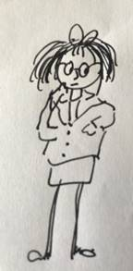

I’d also love to hear from you if you are struggling to find a good assessment model.

Many thanks in advance,

Jess

***Jessica Streeting MA Queen’s Nurse***

Nurse Consultant for Public Health

Quality and Learning Division

Central London Community Healthcare NHS Trust

Mobile: 07810487272

[jessicastreeting@nhs.net](mailto:jessicastreeting@nhs.net)

[jessica.streeting@kcl.ac.uk](mailto:jessica.streeting@kcl.ac.uk)

Twitter @JessStreeting.