Making Connections – Lisa Allen

As a Specialist Community Public Health Nurse (School Nursing) working as a Specialist Nurse for Children in Care, a large part of my role is to complete the annual statutory health assessments for children and young people in care to ensure their health needs are addressed.
This is when I met young person A. Her annual health assessment was due, so I arranged to visit her at home to complete this. Young person A was 17 years old and had just moved into her own flat which had a ‘floating’ support worker (a couple of hours support each week). The interesting thing about young person A was that she had an unusual name that I recognized. It so happened that 10 years earlier, when I had been a School Nurse in a different area, I had met young person A and completed her health assessment. This was an instant hit with young person A, and she wanted to know what she was like as a young child. This was the first time I thought about relationships and connections we take for granted, most people would ask family members about their childhood, children in care don’t always have this option.
We know from research and the voice of children in care that knowing and understanding their health history is of vital importance not only in terms of medical/genetics but crucially forms a key part of their identity, belonging thus promoting positive mental health and self-esteem.
https://www.nice.org.uk/About/NICE-Communities/Social-care/Tailored-resources/LACYP
https://www.nice.org.uk/about/nice-communities/social-care/tailored-resources/lacyp/statement-4
https://assets.publishing.service.gov.uk/government/uploads/system/uploads/attachment_data/file/413368/Promoting_the_health_and_well-being_of_looked-after_children.pdf
During my visit she showed me her several pet hamsters whom she loved dearly. She cared for them, provided luxury accommodation, and spoke about their different personalities fondly. Young person A, like a lot of the young care leavers I see, was not in employment or education. I asked her if she would like to visit the local donkey sanctuary with me as I had recently made connections there and told her there may be opportunities to do a course or take part in therapy (donkey therapy!). She was keen and the next week we visited the donkey sanctuary. Young person A was a natural with the donkeys and keen to start a donkey management course – learning all about donkey care, she even had a go at cleaning the donkey hooves. Unfortunately, the week after this COVID hit and the first lockdown began meaning the donkey sanctuary was closed.
For many looked after children/care leavers, attachment poses a huge challenge with life-long impact on their outcomes. Pets/animals have proven to be a powerful medium through which to address this, with positive impact; in times of transition, they can, managed well, be a catalyst to positive moves.
https://www.iriss.org.uk/resources/insights/attachment-informed-practice-looked-after-children-young-people

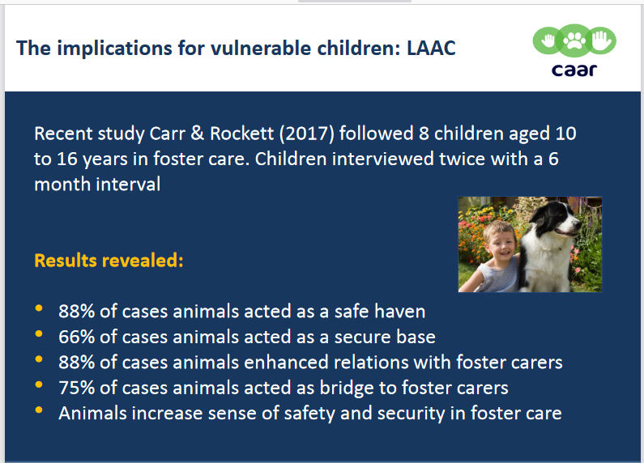
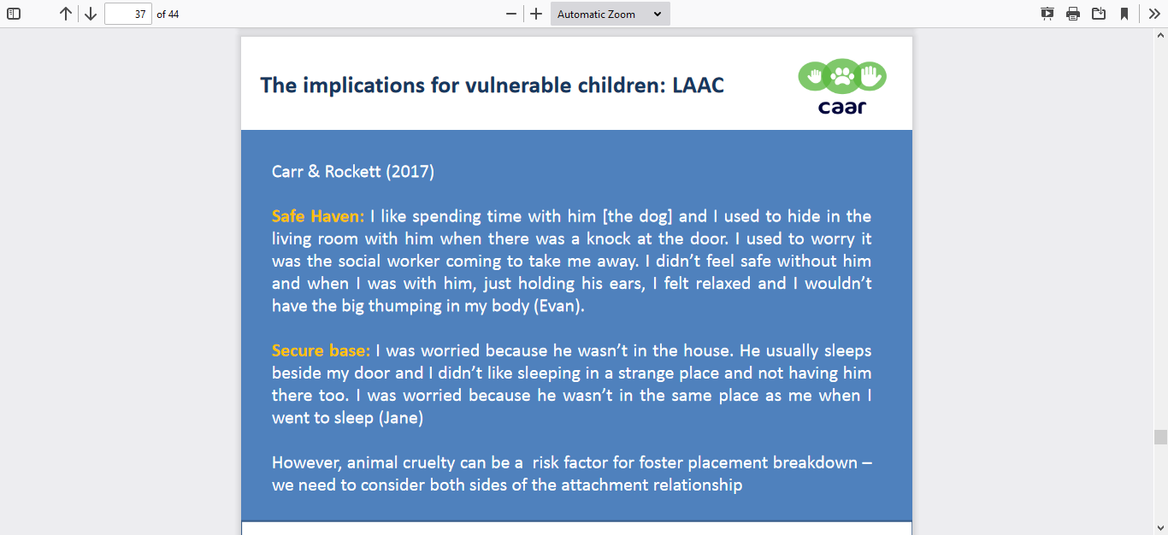
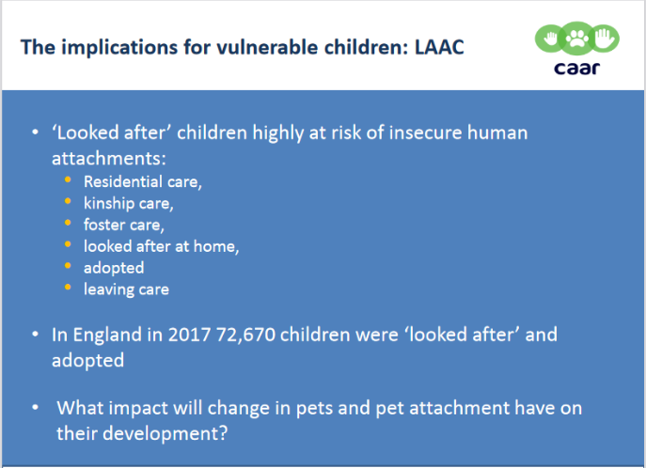
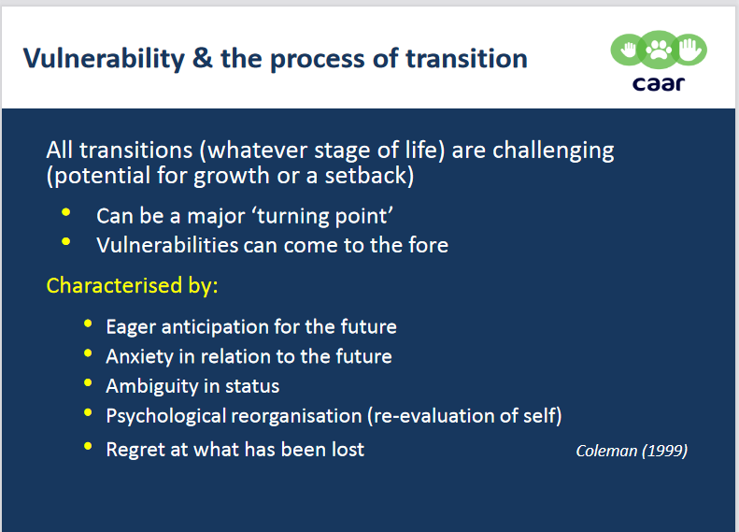

https://www.ed.ac.uk/files/atoms/files/workshop_2_powerpoint_slides.pdf
A couple of weeks later young person A became 18 years old. As a Specialist Nurse for Children in Care part of my role is to also support care leavers – that is those young people over 18 until they are 25 years old. I telephoned her a few days after her birthday, she was 18 years old so no longer had a Social Worker, she was living in a flat, had several hamsters to care for and there was a National lockdown. Inevitably her mood became low, and she was struggling to manage her finances – she had also just bought a kitten so had cat food as well as hamster food to buy. Fortunately, she also had a boyfriend (whom I had met several times) who helped her by going to local foodbanks and making sure she always had enough food in the flat. I continued to offer emotional support.
As I had kept in touch with the donkey sanctuary, I was able to pick up some sawdust shavings several times throughout lockdown for her hamsters bedding as they kindly offered this. Young person A and her boyfriend were delighted with this and I used to meet them in the car park of her flat to handover sawdust and have a chat. I could tell that this gesture from the donkey sanctuary meant a lot, they had remembered who she was and wanted to help her. We know that a disproportionate number of Care leavers become NEET, key to changing this is the formation of consistent, trusting relationships with adults who support them to develop life-skills often missing or impacted negatively by their life-experiences. Where this is delivered well, many can and do move onto successful further education and/or employment.
https://impact.barnardos.org.uk/our-work/positive-futures
We kept in touch throughout lockdown mainly by text and telephone calls (apart from the sawdust drop offs). Then one day I got the excited ‘I’ve got something to tell you’ telephone call… young person A was expecting baby. They were really pleased, and I congratulated them on their news. I then made connections with the young person’s midwives in our local area to share health information to ensure they could support young person A holistically, which they did do amazingly.
A few days ago, I got a telephone call from young person’s A boyfriend telling me she was in hospital, she had been induced and baby was on her way (they knew it was a girl already). He was so excited on the phone and told me all about what the Nurses had said etc. I wished them well and he asked if he could ring me when baby was born hopefully tomorrow…which of course I said he could.
The fact that he had rang me made me think. In that situation most people ring relatives, friends, loved ones. For young care leavers this may not be an option. They may not have had consistent family members or long-term friendships as they have moved between schools, placements, or areas throughout their short lives. In fact, young person A had moved to 4 different schools and several placements since I had first met her all those years ago.
The fact that I was a person he chose to ring meant I was a trusted, reliable, consistent connection. It was not so much about me as a Nurse or as a person, it was the fact that I was there, I cared, I kept in touch.
This highlighted to me how important these connections are, particularly during times of transition when things change and even more so during COVID. The person he rang could have been a support worker, a School Nurse, a Leaving Care worker…we all have a part to play. We all could be that reliable person who cares. We take for granted our own ‘connected’ people... our partners, parents, family members… but for some care leavers it is us.
https://www.rcpch.ac.uk/resources/looked-after-children-lac

