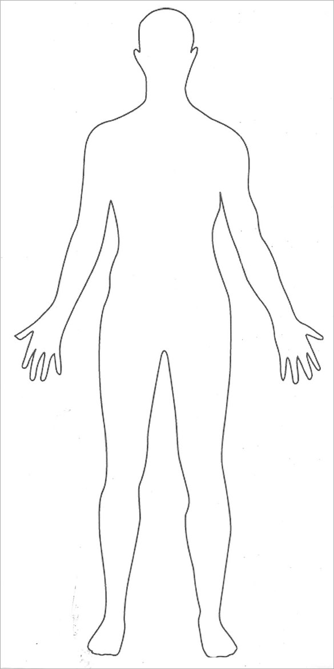

Heart beating quicker.

Can’t breathe.

Tight chest.

Jelly legs.

Pins and needles.

Feeling sick.

Headache.

Going to the toilet more often.

Sweating.

Butterflies in tummy.

Goosebumps.

Feeling hot.

Lump in throat.

Dry mouth.

Twitching.

Ringing hands.

Tapping feet.

Stomach in knots.

Tense shoulders.

Breathing quicker.

Feeling dizzy.

Can’t think.

Trouble eating.

Trouble sleeping.

Dry mouth.

Difficulty talking.

CIRCLE THE BODY SIGNALS THAT YOU RECOGNISE.