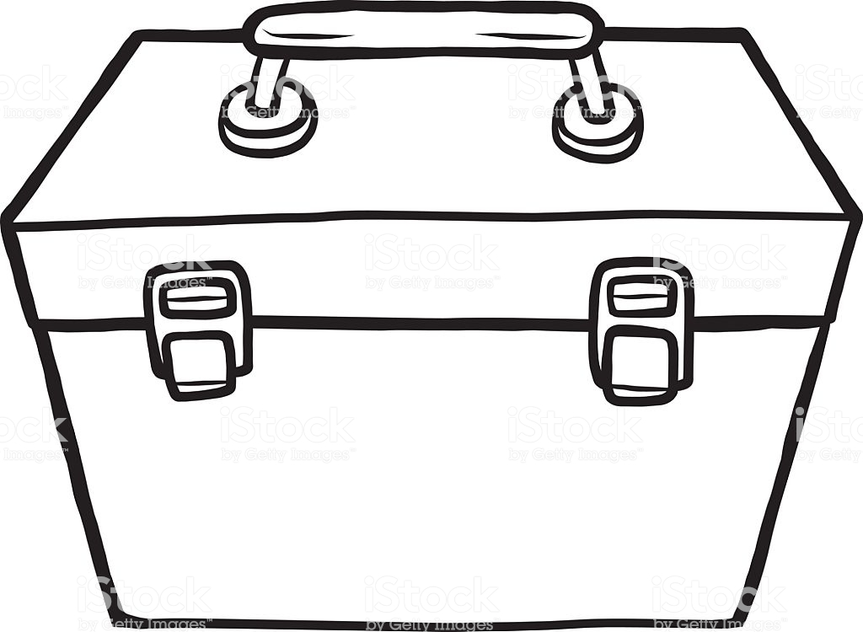

EMOTIONAL TOOLKIT.

WHATS IN YOURS?