Public Health England

Case Studies and Local Practice Examples Templates
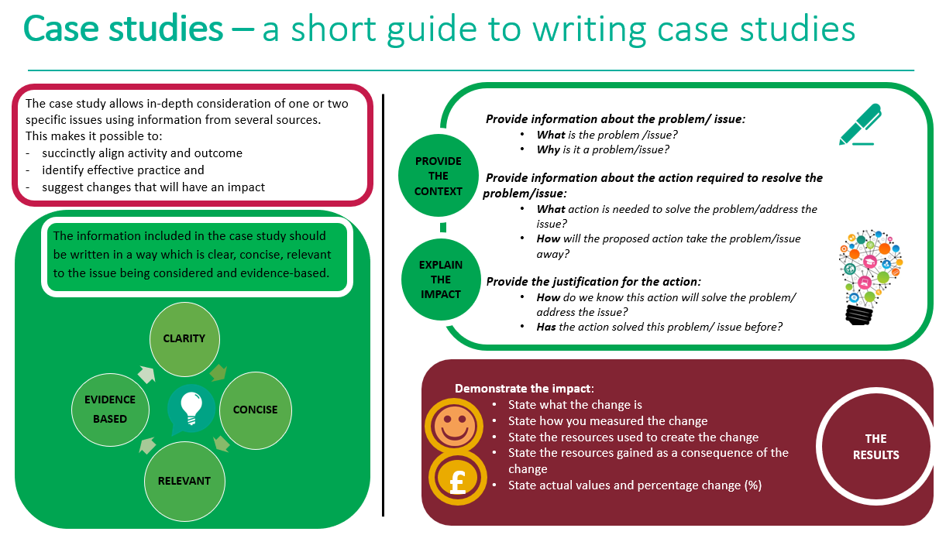

Case study template
Title (Word count 50 max)
Choose a short title which reflects the case study and captures the readers interest
Author: add contact details
Context (Word count 250 Max)
- What was the current situation?
- What is the problem/issue?
- What is the reason for the change?

Solution (Word count 200 Max)
- What is the proposed change?
- How will this change improve the situation?
Action (Word count 300 Max)
- What will be done?
- How will it be done?
- Why will this be done?

Outcome and Impact (Word count 500 Max)
- What is the actual outcome?
- What is the actual difference the change has made?
- Use quantitative (hard), qualitative (soft) and cost (financial) data to describe the change
Lessons Learned and Recommendations (Word count 500 Max)
- What worked well?
- What could be done differently?
- How will the change be sustained over time?
- Use quotations to illustrate the difference the change has made to people
References
- State the research study which illustrates how the chosen action has achieved the preferred outcome
- Use the Harvard referencing system

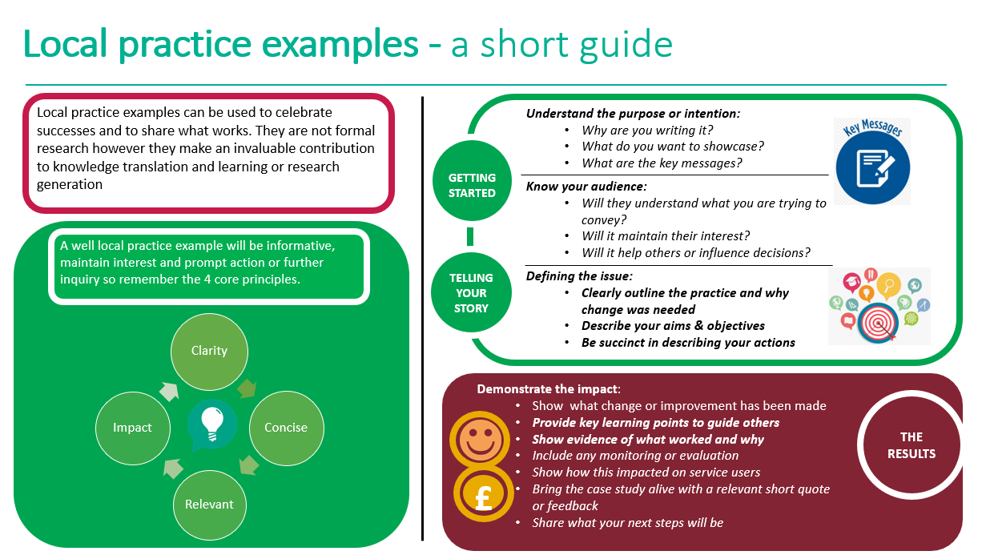
Local practice example template

Title (Word count 65 max)  Include a short descriptive title which reflects the key focus and main benefit  Author: add contact details | Learning to manage worries; A brief intervention for year 6 children across Sefton, to prepare them for SATS and transition to High School.  Catherine Brindle. Specialist Children’s Nurse, Emotional Health and Well-being. RGN/RSCN BSC with HONS CAMHS. 07867187632
Description (Word count 100 Max)  Include a short focused description of your practice example & the main benefit | Across Sefton, School Nurses were seeing a large number of year 6 children who were worried about SATS and transitioning to High School. This anecdotal evidence was also supported by an on line questionnaire that year 6 children were completing prior to SATS and transition.  In order to address this need the Emotional Health and Wellbeing Service, (EHWB) developed and wrote a 2 session intervention for year 6 children to support them to manage worries.  The main benefit for doing this was to encourage resilience in children and future life skills, it also aligned with Sefton’s strategic plan in supporting the emotional and mental health of children and young people.  By addressing and responding to the information from the questionnaires, it supports a Public Health approach and aligns to “The Future in Mind” document, 2015 , in respect of early identification, and early intervention.
Context – what was the aim? (Word count 150 Max)  - Provide a concise overview of your aims and objectives  - Describe the starting point, baseline and include useful data about population or demographics  - Explain how the need arose | The aim was to support the emotional health of children, teach resilience and respond to demand. In conjunction with school health, the EHWB specialist nurse wrote a 2 session intervention based on Cognitive Behavioral Therapy, (CBT) to support year 6 children to recognize and manage worries.  The intervention was piloted and evaluated in one primary school initially. Feedback informed by the evaluation of pupils and head teacher indicated that the interventions were successful in managing worries, particularly during SATS week.  The head teacher of the pilot primary school was so impressed with the intervention, she discussed and recommended it to the cluster of primary schools that she linked to, and it was piloted again the following year in six primary schools.
Method – what did you do? (Word count 200 Max)  Provide clear details of:  - What activity you undertook  - Who was involved and why | The EHWB specialist nurse researched the efficacy of a CBT approach, which influenced her writing of the 2 session intervention. CBT has a very strong evidence base in terms of managing difficulties such as anxiety, and depression, particularly in adults. There is also strong evidence of its success in children and young people, as evidenced by Paul Stallard, “Think Good Feel Good” 2016..  The intervention had to be age appropriate, easy to understand and easy to deliver by school nurses, who are not, necessarily, trained in early intervention activities or feel confident to do so.  CBT looks at thoughts, feelings and behaviors’ and makes connections between all of these. This was an excellent staring point as the intervention was written to enable year 6s to understand what worry is, the purpose of worry and how it can affect their thoughts about certain situations, i.e SATS and moving up to High School, how it affects them physically, i.e butterflies in their tummies, and then how this links to their emotions, they may become scared, fearful, and then how this links to behavior, i.e. they may become moody or they may avoid certain situations.  As this was introduced and explained to year 6 pupils, the school nurses were also able to understand the dynamics of worry and behavior.  As the second year of the pilot gained momentum, school nurses from other areas in Sefton were invited to attend the sessions, so that they could upskill and see the benefit of the intervention.  The intervention is very active and positively engages young people, with activities and discussions, and school nurses informed me that this is a very rewarding part of their job, and that they enjoyed the positive interaction with young people in order to promote and raise the profile of the school nursing service in Sefton.  School Nurses also wanted to learn early intervention EHWB techniques to support young people on their case load, and found this to be very accessible in terms of their learning and enhancing their practice skills.
Outcomes – what difference did you make? (Word count 200 Max)  - How was this measured?  - Can you show evidence of impact?  - What has changed?  - Was there any user feedback?  - Was this value for money / did you make any savings? | The intervention was measured by evaluation’s completed by the year 6 children, the class teacher, and feedback from the school nurses. We also had feedback from head teachers in the form of thank you letters, and one head teacher reported that he had the best ever year 6 SATS results, and felt that the intervention had contributed to this.  Children were invited to write what they had learnt and what difference, if any ,it had made to them. Comments were varied, however the most common themes are that they know how to recognize and manage worries now, they know that they are not the only person who worries, and it is normal to worry, they know it is ok to ask for help. Children expressed a preference for strategies to help manage worries, such as mindful breathing, finger breathing, guided visualization, positive thoughts and personal positive statements. Over all, children wanted more sessions, many of the evaluation forms asked when we would come to see them again.  Feed back from school nurses informed me that it was their favourite intervention that they delivered, it was accessible and flowed well when delivering, and the interaction with the children was positive, it also helped them identify children in the class who might be struggling, and how they could potentially target these children further.  Although initially school nurses were weary of the time impact of delivering the interventions, it actually saved them time, particularly when the sessions were delivered prior to the year 6 life style questionnaires, as the school nurse’s could target the children who alerted on the questionnaires and supported them to remember the strategies’ they had learned in the sessions, rather than completing individual interventions, or starting from the beginning.
Key learning points (Word count 500 Max)  Provide key areas of:  - What are the key learning points and what worked well?  - What things you might do differently  - What future plans do you have to embed this? | The key learning points are to make the intervention not only accessible to children and young people, but to school nurses also. It is documented in and RCN survey of School Nurses, that School Nurses lack confidence, or do not feel that they have the correct skill set and knowledge base to deliver early intervention work to support childrens mental health. RCN School Nurse Survey 2016.  Being supported by the EHWB specialist nurse to co facilitate the sessions has been a key learning point. This has enabled reflective feedback on what went well during delivery, and what we can work on to improve the school nurses delivery and that of the EHWB specialist nurse also. Working together with a specialist nurse promotes growth and confidence in the work force, it helps to de mystify childrens mental health and enables the school nurse to recognize the key role that they play in young people’s lives in respect of early intervention in mental health and wellbeing and the differences that it can make.  School nurses in Sefton welcome and value the role of the EHWB specialist nurse. Key learning points are that they feel supported, and the role is accessible, as the EHWB specialist nurse also works on the “coal face” and understands the difficulties not only for practitioners but for young people as well.  Due to the Covid 19 pandemic, we have had to think of different ways to continue to deliver the managing worries sessions to our year 6 pupils. With this in mind, the EHWB specialist nurse filmed the sessions, and the links have been sent to schools, along with the interactive resources in order for the intervention to be delivered virtually. This has worked out well, as we have had new starters in place who had yet to be trained by the EHWB specialist nurse to deliver the intervention. Due to this, we have been able to be equitable in delivery across Sefton; the intervention has also been shared with neighboring boroughs and distributed via our comms to our NWBH family, who may have their own children transitioning to High School, it has also been shared to the weekly school cells meeting, and cascaded through their network as well as my weekly newsletter to school nurses.  Embracing technology has been a key learning point for me. Filming the sessions has ensured equity and consistent messages are going to year 6 children, future plans are to film some assemblies for our year 7 children when they have transitioned to High School to ensure continuity of support messages for this co hort of children.  Delivering the sessions initially face to face has supported the evidence base to move this intervention onto film. The intervention is evaluated very positively, which has given the specialist nurse the courage to take things forward. We know that the interventions shown in the films work, as the specialist nurse has been approached by young people now in years 8 and 9 who remember and practice the interventions to support them to manage worries.  I will utilize the films for future training for the school nurse in this intervention, as it will support them with delivery and confidence.  Although filming has felt at times very much outside of my comfort zone, it has certainly encouraged me to embrace technology and to try new things, such as virtual appointments with families.  Commissioner’s and managers have been pleased with this piece of work, as it has meant that during covid 19 we still been able to deliver a school health service, al be it a virtual one.
References
Include relevant links and references where appropriate

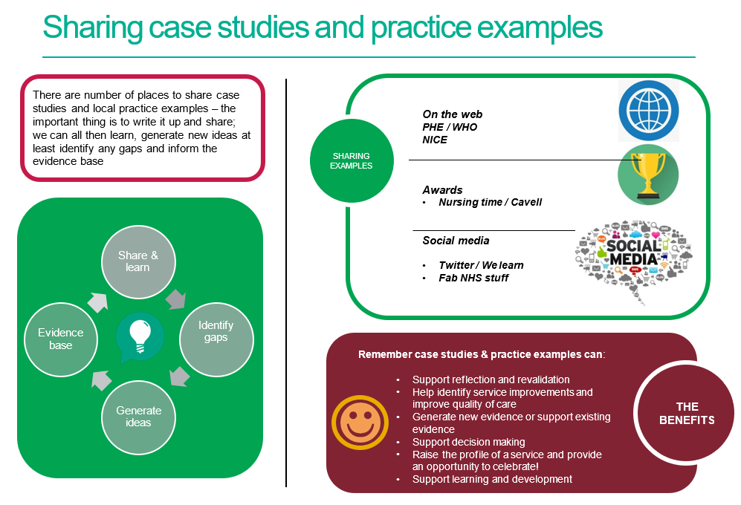

References / further reading

https://www.rcn.org.uk/professional-development/nice-collaboration/nice-case-studies

http://www2.hull.ac.uk/lli/pdf/Case%20Studies.pdf

https://www.brookes.ac.uk/students/upgrade/study-skills/reflective-writing-using-gibbs/

http://www.euro.who.int/en/health-topics/Life-stages/child-and-adolescent- health/publications/2013/improving-the-lives-of-children-and-young-people-case-studies-from- europe.-volume-1.-early-years

http://www.nesta.org.uk/centre-social-action-innovation-fund-evaluations/nesta-standards- evidence

Please complete and return your Case study/ Practice example to:
WHO Collaborating Centre for Public Health Nursing and Midwifery) on: nme.whocc@phe.gov.uk

