Public Health England

Case Studies and Local Practice Examples Templates
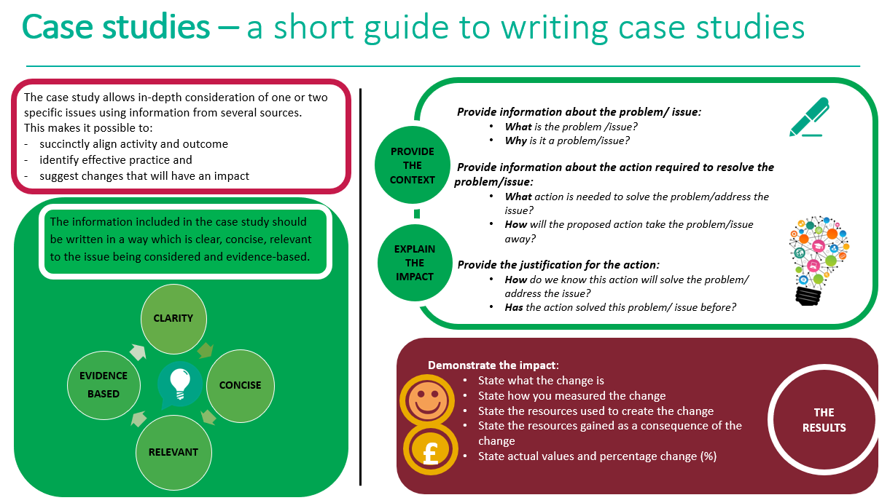

Case study template
Title (Word count 50 max)  Choose a short title which reflects the case study and captures the readers interest  Author: add contact details | School Nursing Public Health videos
Context (Word count 250 Max)  - What was the current situation?  - What is the problem/issue?  - What is the reason for the change? | The School Nursing team, including our High Impact Assessment (HIA) lead for mental health in school aged children, and Health for Life teams usually see children and young people in school.  With schools largely closed due to Covid-19, the team wanted to identify a way to support families to adapt to the new situation, and still continue to promote important public health messages they would normally be delivering at this time in schools.  This group of colleagues do not usually work together, but through the use of Microsoft Teams and teleconferences, they met and developed the primary and secondary school packs.
Solution (Word count 200 Max)  - What is the proposed change?  - How will this change improve the situation? | Electronic resource packs were developed for primary and secondary school age groups which included:  - Staying well at home – focusing on how to support positive mental health  - Top tips for keeping fit while at home  - Recipe ideas  Both primary and secondary school packs aim to integrate the physical health and mental health and wellbeing elements to reinforce how physical and mental wellbeing are closely related.  Both packs covered handwashing, healthy eating, connecting with friends and different activities that could be done throughout the day. The packs also include links to online resources for families in a range of circumstances, such as information relating to autism.  The secondary school pack also included a section discussing suicide prevention and a section on sexual health.  These were promoted via schools and located on our school nursing website https://www.healthmatters.clch.nhs.uk/  Recognising that many teenagers would rather watch film clips than read it was decided that videos would be developed that were suitable for now and in the future regardless of whether we were restricted as to what we could do and how we could interact.  The electronic resources became 3 videos for your people to access:  - Mental health and wellbeing  - Fitness and physical activity  - Healthy eating
Action (Word count 300 Max)  - What will be done?  - How will it be done?  - Why will this be done? | The electronic resource packs have been distributed to schools in all seven boroughs where CLCH deliver school nursing services. We also make the packs available to parents who ring our advice line.  The feedback we have received from schools and families so far has been really positive.  To develop the videos the school nursing team who had developed the resources worked together to produce the scripts for the videos. This included student SCPHN school nurses who were able to engage in this as part of alternative practice as for many their original plans had been cancelled due to Covid.  Young people were consulted on what they would like from a video and efforts were made to plan the content to be engaging for young people. This included using animation and keeping the videos short with lots of activity.  Copia a professional production company were commissioned to produce the videos and a day of filming was held for the live content using social distancing practices and future days are planned for the animation and voiceover work to take place.  The videos will sit on our school nursing webpages where you can also view the electronic resources (see tabs for Primary school resources and secondary school resources) https://www.healthmatters.clch.nhs.uk/  It is hoped that these resources will be engaging for young people and provide health promotion messages in a format that they can access.
Outcome and Impact (Word count 500 Max)  - What is the actual outcome?  - What is the actual difference the change has made?  - Use quantitative (hard), qualitative (soft) and cost (financial) data to describe the change | The videos are still in the production phase and are expected to be ready towards the end of the school holidays. They will be promoted via schools, school nursing interactions and social media to encourage young people to access them.  While we are positive about getting back into schools to support our children and young people we are also aware that there will be some limitations so have looked for new and innovative ways to deliver public health messages.  This piece of work was not a cost saving exercise but an effort to provide something to help our children, young people and families during this difficult time we hope that the videos will be a helpful resource now and in the future. As such we do not have any data to evidence the impact.
Lessons Learned and Recommendations (Word count 500 Max)  - What worked well?  - What could be done differently?  - How will the change be sustained over time?  - Use quotations to illustrate the difference the change has made to people | Bringing the school nursing team together to create these innovative resources was fantastic. Keeping the script development in particular at this level with senior sign off but not development meant that the video content was creative, less formal and developed by people who work with young people.  In a non-covid environment we would have had young people in the films but we were restricted by social distancing and needing to limit and rationalize bringing young people into contact with health professionals.  We did a lot of the filming outside which was great as it made it more dynamic and safer from a Covid perspective. The filming was based at one of our children’s centers and a green screen was used so we can make the backgrounds animated and engaging.  We are also developing a further video on the role of the school nurse and further developing our website content to better meet the needs of young people.  Top tips from young people  “A good video for a teenager is a video which information is being explained clearly, using examples where/when possible and good quality. It also has to catch the teenager’s attention- talk about things which could be useful and interesting to them.”  “In my opinion, nowadays young people like to watch teen-oriented content on YouTube. Some examples of what teenagers enjoy watching are:  - Music videos  - Influencer videos  - Video game playthroughs  - How to videos  Young people enjoy watching these kinds of videos because it’s what they find fascinating and also because to them it feels like they could get some creative ideas or learn new things which could be useful for them. “
References
- State the research study which illustrates how the chosen action has achieved the preferred outcome
- Use the Harvard referencing system

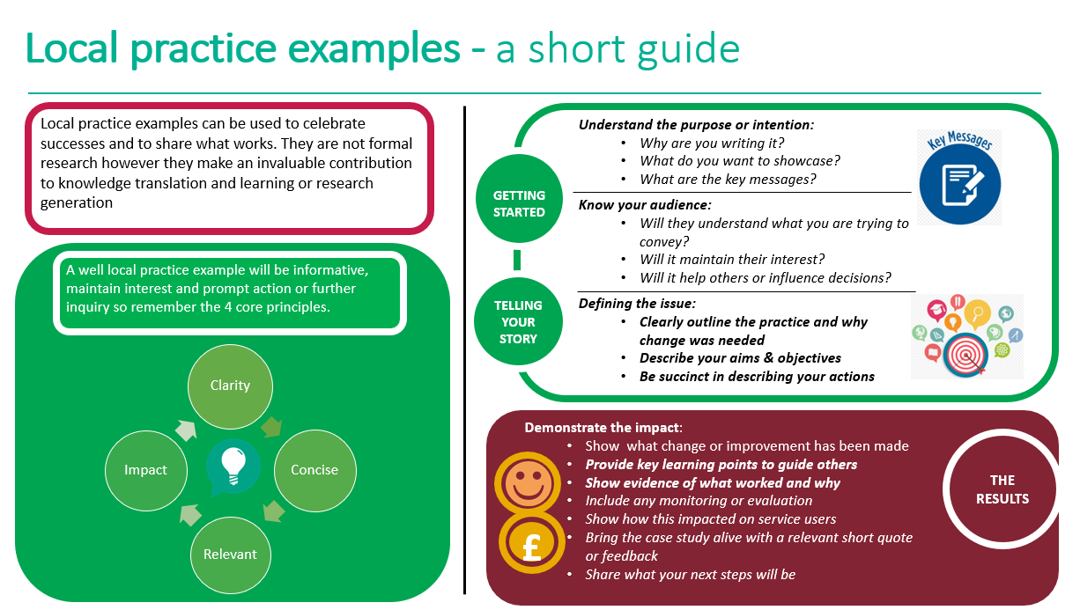
Local practice example template

Title (Word count 65 max)
Include a short descriptive title which reflects the key focus and main benefit
Author: add contact details

Description (Word count 100 Max)
Include a short focused description of your practice example & the main benefit

Context – what was the aim? (Word count 150 Max)
- Provide a concise overview of your aims and objectives
- Describe the starting point, baseline and include useful data about population or demographics
- Explain how the need arose
Method – what did you do? (Word count 200 Max)
Provide clear details of:
- What activity you undertook
- Who was involved and why

Outcomes – what difference did you make? (Word count 200 Max)
- How was this measured?
- Can you show evidence of impact?
- What has changed?
- Was there any user feedback?
- Was this value for money / did you make any savings?
Key learning points (Word count 500 Max)

Provide key areas of:
- What are the key learning points and what worked well?
- What things you might do differently
- What future plans do you have to embed this?
References
Include relevant links and references where appropriate

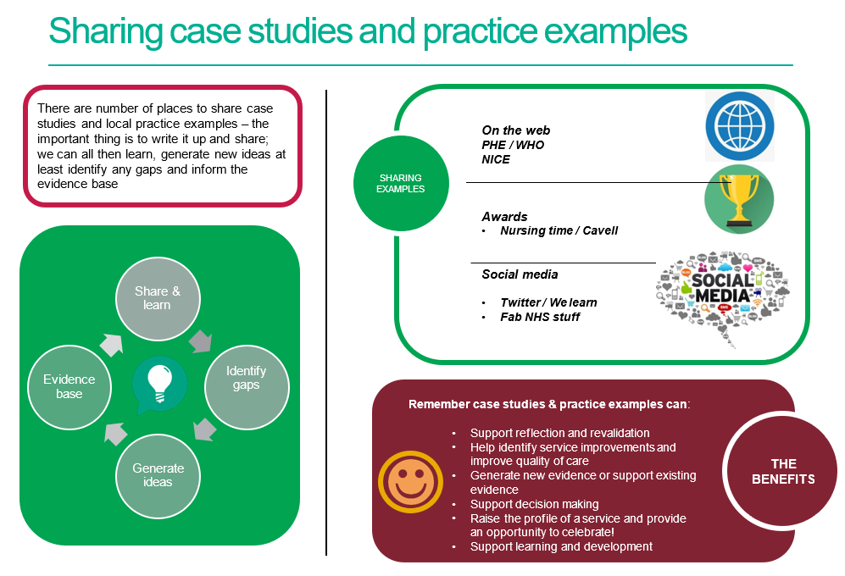

References / further reading

https://www.rcn.org.uk/professional-development/nice-collaboration/nice-case-studies

http://www2.hull.ac.uk/lli/pdf/Case%20Studies.pdf

https://www.brookes.ac.uk/students/upgrade/study-skills/reflective-writing-using-gibbs/

http://www.euro.who.int/en/health-topics/Life-stages/child-and-adolescent- health/publications/2013/improving-the-lives-of-children-and-young-people-case-studies-from- europe.-volume-1.-early-years

http://www.nesta.org.uk/centre-social-action-innovation-fund-evaluations/nesta-standards- evidence

Please complete and return your Case study/ Practice example to:
WHO Collaborating Centre for Public Health Nursing and Midwifery) on: nme.whocc@phe.gov.uk

