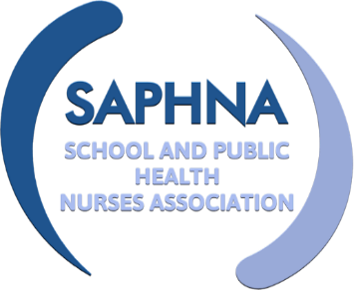SAPHNA ANNUAL CONFERENCE 2021

WORKSHOPS

Choose two workshops per day; all others will be available via a recording following the event.

- Change Your Mind – Peer education mental health programme Sophie McPhee and students Queen Mary’s Grammar School, Walsall SallyAnn Sutton SAPHNA / Walsall 0-19 Service Leader.

- School Screener - Parent Communications: Improve Security, Safety and Speed with the New SchoolScreener Parent Portal’. Presenter Marta Kalas, COO at Thomson Screening

- ChatHealth - An integrated digital offer for Families, Children and Young People: Supporting school nursing teams to implement an award-winning, innovative solution to offer digital access to healthcare advice and support

- Using digital technology to optimise multi-agency safeguarding. The value of integrating resources into practice Caroline Flynn. CEO MAAPP, frontline Social Worker, Team Manager, Child Protection Chair

- The Lancaster Model In partnership with Aire Logic Ltd, to deliver the earliest intervention through Innovative Tech, to significantly improve outcomes for children, young people, and their families

- The key role of School nurses in supporting young people with eating disorders – sharing and learning from my shared lived experience Hope Virgo, campaigner, author, ambassador Shaw Mind Foundation

- The SAPHNA Vision for School Nursing; rhetoric into reality SAPHNA Team

- Showcase of exemplary COVID 19 School Nursing service redesign and offer a selection of x4 case studies Presenters tbc

OPTION 1 | OPTION 2 | OPTION 3 | OPTION 4

PLEASE CONFIRM YOUR WORKSHOP CHOICES, USING THE TABLE ABOVE

DELEGATE NAME
TICKET NUMBER
EMAIL ADRESS

Please send this completed form to SAPHNA at info@saphna.co

