Public Health England

Case Studies and Local Practice Examples Templates
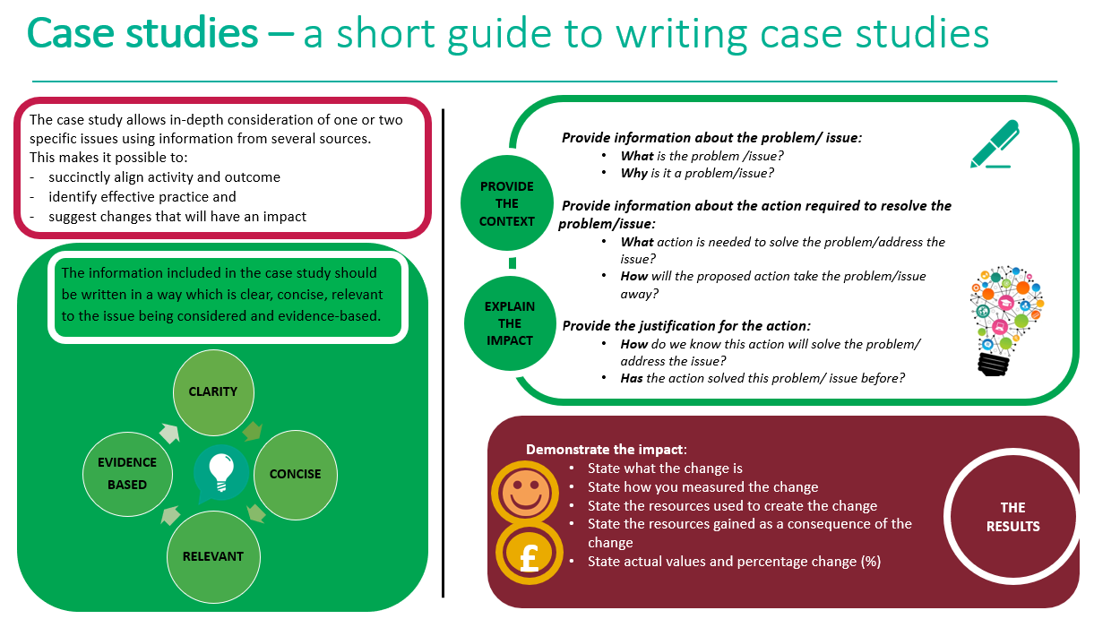

Case study template
Title (Word count 50 max)  Choose a short title which reflects the case study and captures the readers interest  Author: add contact details | Return to school video
Context (Word count 250 Max)  - What was the current situation?  - What is the problem/issue?  - What is the reason for the change? | As children prepare to return to school based education, we were aware that there were anxieties around this, not just for the children and young people (C&YP), but also for their parents and carers. The media is bombarding them with information about the safety of this plan. Even if they have not seen nor heard it, their parents and carers will have, and their feelings and worries will inevitably spill over onto the children. 10+weeks is the longest most of these children will have ever been off school and some return to school anxiety is perfectly normal, even without the added safety worries. We also wanted to remind those C&YP for whom lockdown has not been a safe or nurturing time, how to contact their SHN.
Solution (Word count 200 Max)  - What is the proposed change?  - How will this change improve the situation? | The proposal was to produce a brief video normalising some of their fears and concerns, and highlighting the role of the SHN in supporting with these. I felt that using as many School Nurses within it as possible, would enhance the appeal of the video, increasing the potential audience and interest.
Action (Word count 300 Max)  - What will be done?  - How will it be done?  - Why will this be done? | A script was written collaboratively by one of the school nursing area teams, using questions we had been asked or concerns children had voiced. I wanted it to reflect the real worries we were hearing. The script also included the messages about our service that we wanted to communicate.  The SHN service workforce was emailed and asked if they were willing to record a short section. Those who responded were asked to return the NHS Trust media consent form and allocated a short section from the script to record. For improved viewing, they were instructed to record this in landscape. They were all given 2 additional sections to record with the aim of having all 37 on screen at once for these parts to give emphasis. All the videos were collated in Google Drive and edited together into a cohesive video. Subtitles were added for the hearing impaired and contact details displayed at the end of the video.  Once completed, the plan was for it to be launched through the Trust social media channels- Facebook, Twitter and YouTube- in time for the start of half term and ideally for the Bank Holiday Monday when parents might have more available time to look at social media.  I recognised that parents would probably be the vehicle for ensuring the messages were distributed as the platforms were more adult based. Parents of primary aged children would be aware of the offer of support for their child, and parents of secondary aged children might show it to their child to see if their SHN was represented in the video, or signpost their young person to the service themselves if they were in need of SHN support.  Secondary schools would be sent the YouTube link to share with their pupils after half term.
Outcome and Impact (Word count 500 Max)  - What is the actual outcome?  - What is the actual difference the change has made?  - Use quantitative (hard), qualitative (soft) and cost (financial) data to describe the change | 37 members of the SHN service volunteered to participate, around half of the workforce. The video although ready the weekend before the BH Monday, was authorised for release through personal Twitter and Facebook accounts on Tuesday 26th May and eventually through Trust channels on the Thursday 28th May. It was rapidly shared by the local SHN workforce. At time of writing it has had over 8,000 views and a reach of over 11,000 on Facebook (see graphs below which just reflect SHN Facebook post); nearly 200 views on Twitter but only 183 views on YouTube. The YouTube view rate is anticipated to increase once the secondary schools include the link in their communications with the students and parents. Comms have just boosted the to turn it into a Facebook ad using Covid budget. It is running across Oxfordshire for adults with an interest in family, children and parenting until the end of the week and will be pushed into the feed of people who do not usually follow.  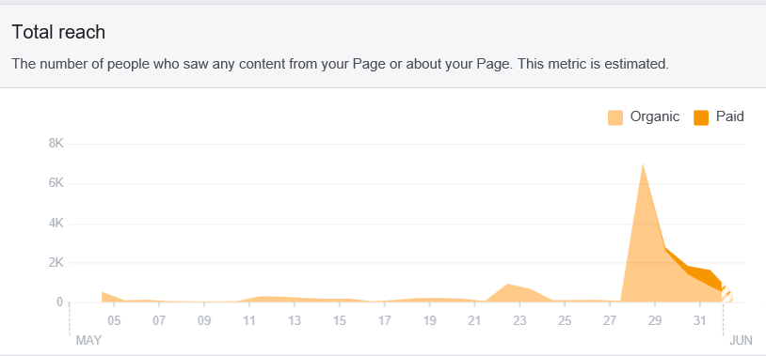  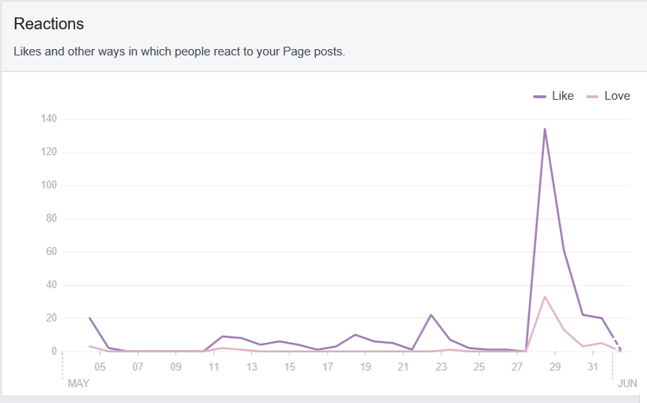  There was no cost associated with this project. Although the collation and uploading was very time consuming, this was completed in my personal time as I felt it was an addition to my professional role and a personal project that was exciting to me. The video editing was generously completed free of charge by a family member who works within the industry and took them approx. four hours.  Beyond the social media statistics, it is too early to provide any further quantative data on the impact of the video. Qualitatively, we have had feedback that parents are viewing and the message of the SHN offer is being seen.  Link to video below:  https://youtu.be/H3W8oPctHdM
Lessons Learned and Recommendations (Word count 500 Max)  - What worked well?  - What could be done differently?  - How will the change be sustained over time?  - Use quotations to illustrate the difference the change has made to people | This has been a well viewed and shared post. We know from the analytics of our Facebook page, when specific staff are mentioned or featured, the post gains more traction.  I had the concept and creative vision, but had omitted to seek official authorisation from our Trust Communications team and hadn’t really considered this until the afternoon of Friday before the BH weekend. This caused a delay in release of the video due to the reasonable communication difficulties given it was a BH weekend.  We have a well embedded, but small Social Media team of two within our service who take responsibility for managing the Facebook page, sharing information and monitoring responses. Once the video had received sign off by the senior leadership team, they were able to share quickly.  Unfortunately, due to the size of the Social media team, we do not have a SHN Twitter profile or input in any more young person friendly platforms. This is a gap we are seeking to address by training up this years SCPHN students and inviting them to join the Social Media Special Interest Group.  With regards to the workload, management of the social media consent forms could have been streamlined by asking participants to individually upload the consent into a folder.  This project was enjoyable and required minimal resource to achieve. This has the beauty of not needing any further work, the video will be shared by viewers and is seen as a ‘once off’ intervention to normalise return to school worries and raise the profile of the support available from the SHN team.
References  - State the research study which illustrates how the chosen action has achieved the preferred outcome  - Use the Harvard referencing system | Young Minds (no date) Life on the web Young Minds, viewed 1st June 2020, <https://youngminds.org.uk/get-involved/campaign-with-us/life-on-the-web/>

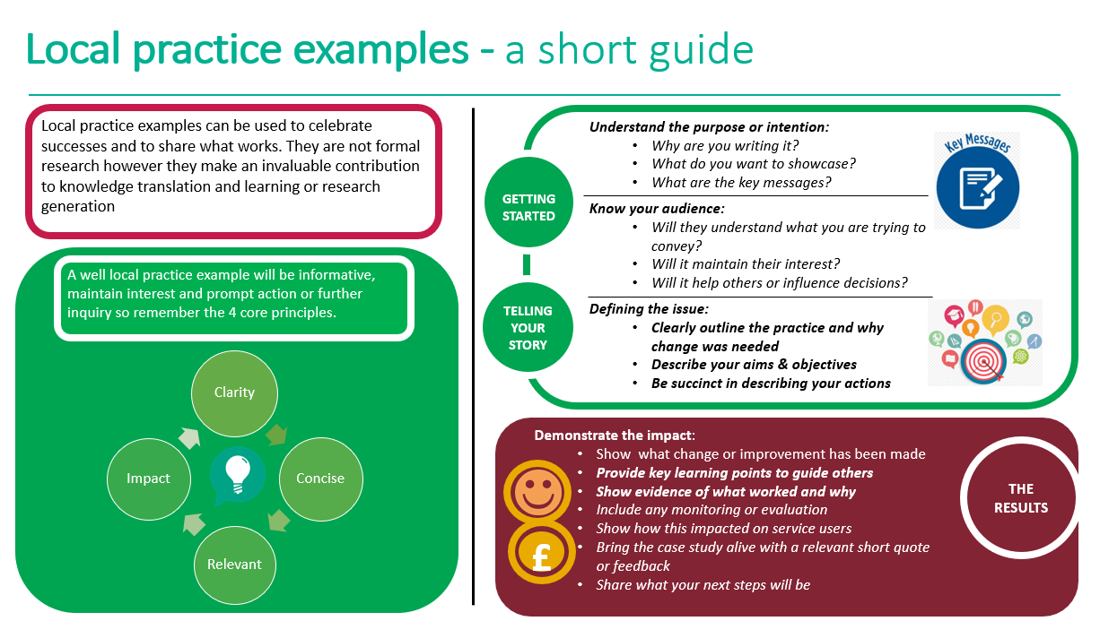
Local practice example template

Title (Word count 65 max)
Include a short descriptive title which reflects the key focus and main benefit
Author: add contact details

Description (Word count 100 Max)
Include a short focused description of your practice example & the main benefit

Context – what was the aim? (Word count 150 Max)
- Provide a concise overview of your aims and objectives
- Describe the starting point, baseline and include useful data about population or demographics
- Explain how the need arose
Method – what did you do? (Word count 200 Max)
Provide clear details of:
- What activity you undertook
- Who was involved and why

Outcomes – what difference did you make? (Word count 200 Max)
- How was this measured?
- Can you show evidence of impact?
- What has changed?
- Was there any user feedback?
- Was this value for money / did you make any savings?
Key learning points (Word count 500 Max)

Provide key areas of:
- What are the key learning points and what worked well?
- What things you might do differently
- What future plans do you have to embed this?
References
Include relevant links and references where appropriate

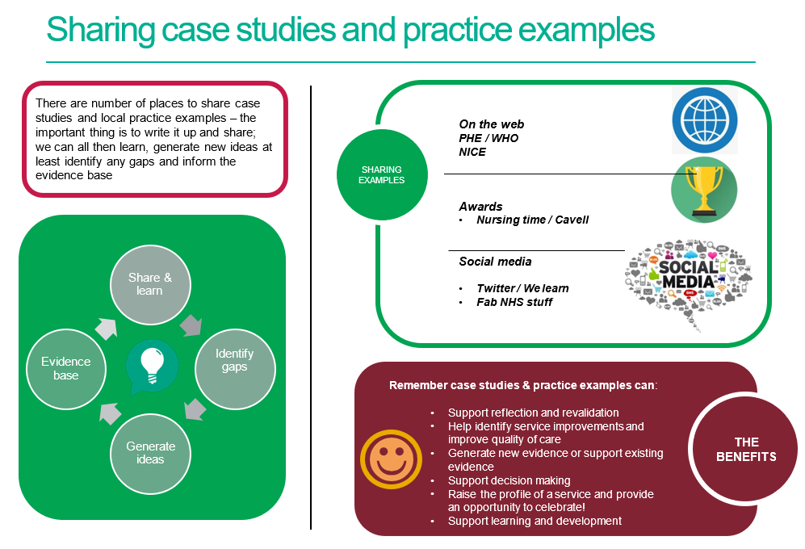

References / further reading

https://www.rcn.org.uk/professional-development/nice-collaboration/nice-case-studies

http://www2.hull.ac.uk/lli/pdf/Case%20Studies.pdf

https://www.brookes.ac.uk/students/upgrade/study-skills/reflective-writing-using-gibbs/

http://www.euro.who.int/en/health-topics/Life-stages/child-and-adolescent- health/publications/2013/improving-the-lives-of-children-and-young-people-case-studies-from- europe.-volume-1.-early-years

http://www.nesta.org.uk/centre-social-action-innovation-fund-evaluations/nesta-standards- evidence

Please complete and return your Case study/ Practice example to:
WHO Collaborating Centre for Public Health Nursing and Midwifery) on: nme.whocc@phe.gov.uk

