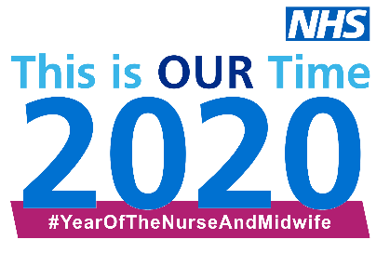
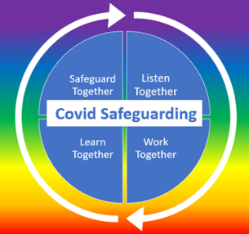
This is our time to be brave and bold to safeguard everyone who might require support in their trauma informed journey.

NHS Safeguarding and partners are delighted to present to you the legacy from our fabulous fortnight event in June 2020
Please join us on the safeguarding FutureNHS workspace and @NHSSafeguarding for more blogs and updates

Date and Time  (Attendee Links will take you directly to Microsoft Live Event) | Topics and Themes | Speakers
Recordings of Previous Live Events
Friday 12th June  Did you follow  @NhsSafeguarding? | Child sexual abuse awareness | Thank you to those that contributed to #PurpleSummer
Tues 16th June 6-7pm  Watch Recorded Live Here | ICON- Babies cry you can cope pathway  Attunement and Early Years Interventions | Dr Suzanne Smith, Founder and Chief Programme Advisor, ICON COPE  Lynne Reed, Director FNP National Unit, PHE
Wed 17th June 12-1pm  Watch Recorded Live Here | School Health and Trauma Informed Practice  Barnardo’s COVID Mental Health & Wellbeing | Sharon White, CEO, SAPHNA  Paula Timms, Acting Head of Health  Lois Wignall, Assistant Director, Children’s Services  Barnardo’s
Thurs 18th June 12-1pm  Watch Recorded Live Here | Safeguarding in a Safe Abortion Service  Children & Young Peoples Sexual Assault Services | Amy Bucknall, UK Named Nurse Safeguarding Children and Adults, Marie Stopes  Louise Barraclough, Specialist Safeguarding Nurse for SARC, Sexual Health and Exploitation, Northern Devon Healthcare Trust
Tues 23rd June 12-1pm  Watch Recorded Live Here | Honour based abuse  Mankind, Supporting Male Victims of Domestic Abuse | Natasha Rattu, Executive Director, Karma Nirvana  Lori Busch, IDVA, Charity Manager Mankind
Wed 24th June 12-1pm  Watch Recorded Live Here | Bereavement and Think Family  Bereavement and BAME | David Anderson and Claire Langton, Specialist Palliative Care, ELHT  Korkor Ceasar, Designated Nurse for Safeguarding children, WEL CCGs  Yvonne Anarfi, Designated Nurse for Safeguarding Children, NHS Basildon & Brentwood CCG, NHS Thurrock CCG
Thurs 25th June 12-1 pm  Watch Recorded Live Here | Integrated Care Systems – The Future of Integrated Safeguarding | Nick Rudling, Interim Head of Safeguarding, Kernow CCG  Zoe Cooper, Consultant Nurse, Royal Cornwall Hospital Trust and Cornwall FT

