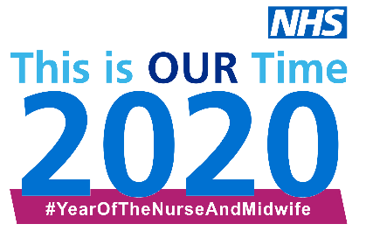
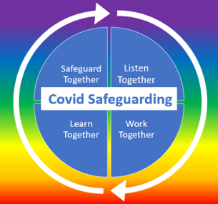
SAVE THE DATES!
We want you to join us for our Safeguarding Fabulous Fortnight
This is our time to be brave and be bold

NHS Safeguarding are delighted to invite you to the following events spanning a safeguarding life course. Anyone can join so feel free to share this amongst your colleagues, these hours will contribute to any level 3 ICD.

Please join us on the safeguarding FutureNHS workspace and @NHSSafeguarding for blogs and updates

Date and Time  (Attendee Links will take you directly to Microsoft Live Event) | Topics and Themes  (titles of presentations TBC) | Speakers
Friday 12th June  All Day on Twitter, follow  @NhsSafeguarding | Child sexual abuse awareness | Please contribute to the twitter discussions using #PurpleSummer
Tues 16th June 6-7pm  Attendee Link  (Please click this link to join the Microsoft Live) | ICON- Babies cry you can cope pathway  Attunement and Early Years Interventions | Dr Suzanne Smith, Founder and Chief Programme Advisor, ICON COPE  Lynne Reed, Director FNP National Unit, PHE
Wed 17th June 12-1pm  Attendee Link  (Please click this link to join the Microsoft Live) | School Health and Trauma Informed Practice  Barnardo’s COVID Mental Health & Wellbeing | Sharon White, CEO, SAPHNA  Paula Timms, Acting Head of Health  Lois Wignall, Assistant Director, Children’s Services  Barnardo’s
Thurs 18th June 12-1pm  Attendee Link  (Please click this link to join the Microsoft Live) | Safeguarding in a Safe Abortion Service  Children & Young Peoples Sexual Assault Services | Amy Bucknall, UK Named Nurse Safeguarding Children and Adults, Marie Stopes  Louise Barraclough, Specialist Safeguarding Nurse for SARC, Sexual Health and Exploitation, Northern Devon Healthcare Trust

Tues 23rd June 12-1pm  Attendee Link  (Please click this link to join the Microsoft Live) | Honour based abuse  Mankind, Supporting Male Victims of Domestic Abuse | Natasha Rattu, Executive Director, Karma Nirvana  Lori Busch, IDVA, Charity Manager Mankind
Wed 24th June 12-1pm  Attendee Link  (Please click this link to join the Microsoft Live) | Bereavement and Think Family  Bereavement and BAME | David Anderson and Claire Langton, Specialist Palliative Care, ELHT  Korkor Ceasar, Designated Nurse for Safeguarding children, WEL CCGs  Yvonne Anarfi, Designated Nurse for Safeguarding Children, NHS Basildon & Brentwood CCG, NHS Thurrock CCG
Thurs 25th June 12-1 pm  Attendee Link  (Please click this link to join the Microsoft Live) | Integrated Care Systems – The Future of Integrated Safeguarding | Nick Rudling, Interim Head of Safeguarding, Kernow CCG  Zoe Cooper, Consultant Nurse, Royal Cornwall Hospital Trust and Cornwall FT

