Public Health England

Case Studies and Local Practice Examples Templates
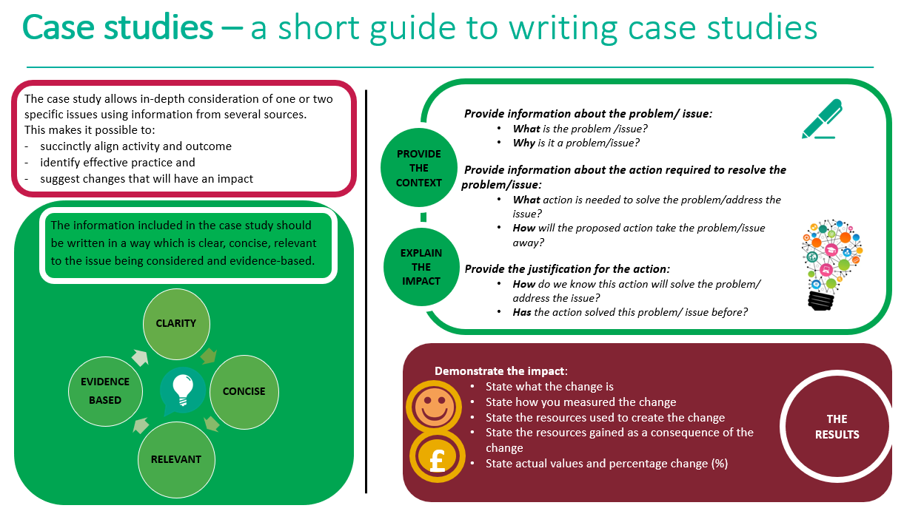

Case study template
Title (Word count 50 max)
Choose a short title which reflects the case study and captures the readers interest
Author: add contact details
Context (Word count 250 Max)
- What was the current situation?
- What is the problem/issue?
- What is the reason for the change?

Solution (Word count 200 Max)
- What is the proposed change?
- How will this change improve the situation?
Action (Word count 300 Max)
- What will be done?
- How will it be done?
- Why will this be done?

Outcome and Impact (Word count 500 Max)
- What is the actual outcome?
- What is the actual difference the change has made?
- Use quantitative (hard), qualitative (soft) and cost (financial) data to describe the change
Lessons Learned and Recommendations (Word count 500 Max)
- What worked well?
- What could be done differently?
- How will the change be sustained over time?
- Use quotations to illustrate the difference the change has made to people
References
- State the research study which illustrates how the chosen action has achieved the preferred outcome
- Use the Harvard referencing system

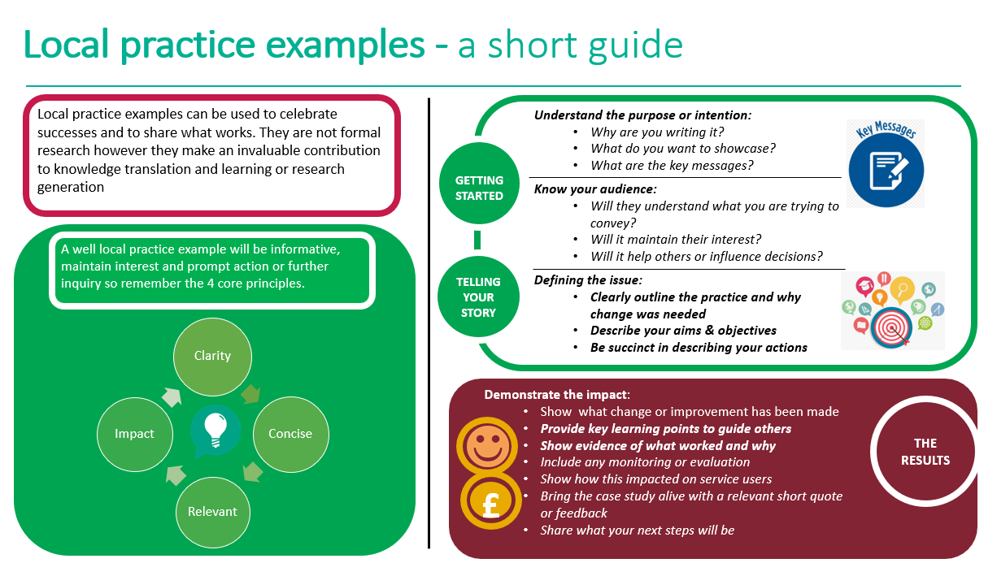
Local practice example template

Title (Word count 65 max)
Include a short descriptive title which reflects the key focus and main benefit
Author: add contact details

Description (Word count 100 Max)
Include a short focused description of your practice example & the main benefit

Context – what was the aim? (Word count 150 Max)
- Provide a concise overview of your aims and objectives
- Describe the starting point, baseline and include useful data about population or demographics
- Explain how the need arose
Method – what did you do? (Word count 200 Max)
Provide clear details of:
- What activity you undertook
- Who was involved and why

Outcomes – what difference did you make? (Word count 200 Max)
- How was this measured?
- Can you show evidence of impact?
- What has changed?
- Was there any user feedback?
- Was this value for money / did you make any savings?
Key learning points (Word count 500 Max)

Provide key areas of:
- What are the key learning points and what worked well?
- What things you might do differently
- What future plans do you have to embed this?
References
Include relevant links and references where appropriate

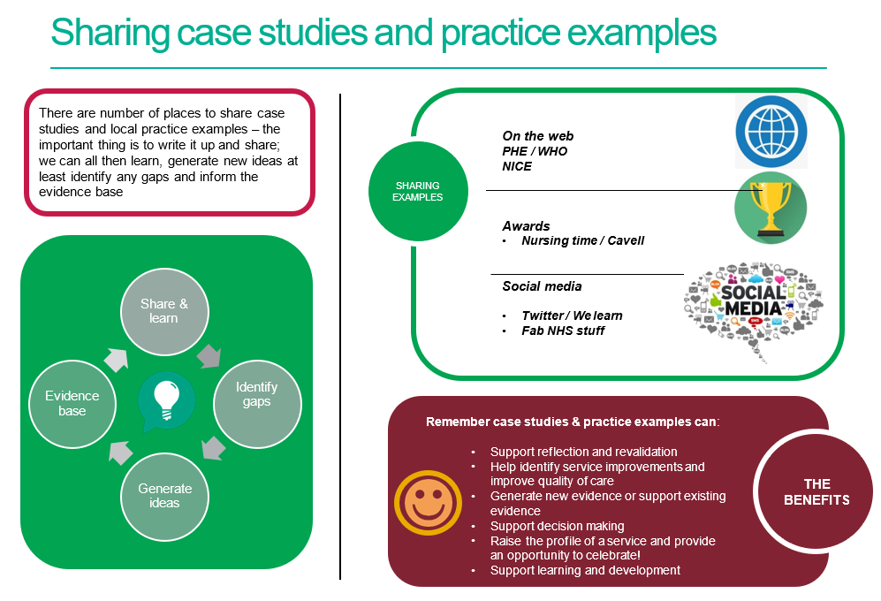

References / further reading

https://www.rcn.org.uk/professional-development/nice-collaboration/nice-case-studies

http://www2.hull.ac.uk/lli/pdf/Case%20Studies.pdf

https://www.brookes.ac.uk/students/upgrade/study-skills/reflective-writing-using-gibbs/

http://www.euro.who.int/en/health-topics/Life-stages/child-and-adolescent- health/publications/2013/improving-the-lives-of-children-and-young-people-case-studies-from- europe.-volume-1.-early-years

http://www.nesta.org.uk/centre-social-action-innovation-fund-evaluations/nesta-standards- evidence

Please complete and return your Case study/ Practice example to:
WHO Collaborating Centre for Public Health Nursing and Midwifery) on: nme.whocc@phe.gov.uk

