Public Health England

Case Studies and Local Practice Examples Templates
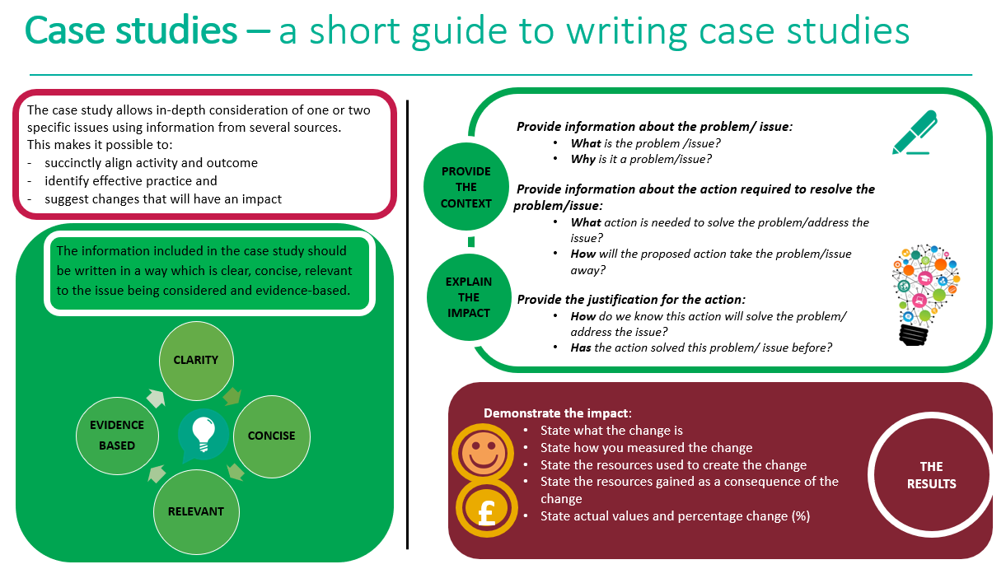

Case study template
Title (Word count 50 max)
Choose a short title which reflects the case study and captures the readers interest
Author: add contact details
Context (Word count 250 Max)
- What was the current situation?
- What is the problem/issue?
- What is the reason for the change?

Solution (Word count 200 Max)
- What is the proposed change?
- How will this change improve the situation?
Action (Word count 300 Max)
- What will be done?
- How will it be done?
- Why will this be done?

Outcome and Impact (Word count 500 Max)
- What is the actual outcome?
- What is the actual difference the change has made?
- Use quantitative (hard), qualitative (soft) and cost (financial) data to describe the change
Lessons Learned and Recommendations (Word count 500 Max)
- What worked well?
- What could be done differently?
- How will the change be sustained over time?
- Use quotations to illustrate the difference the change has made to people
References
- State the research study which illustrates how the chosen action has achieved the preferred outcome
- Use the Harvard referencing system

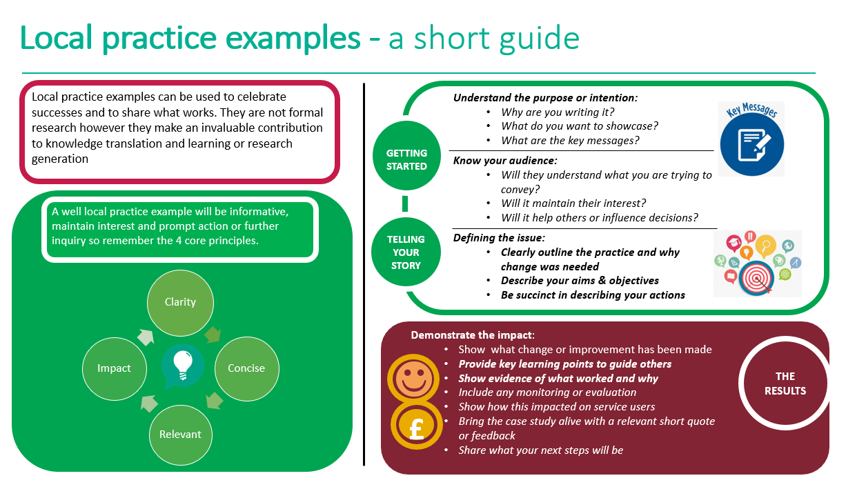
Local practice example template

Title (Word count 65 max)  Include a short descriptive title which reflects the key focus and main benefit  Author: add contact details | Simple and Supportive Measures to help your child’s transition back to Primary School following the COVID-19 Pandemic – a resource for parents and carers to support the preparation for returning to school during this time of uncertainty and fear. Reception / Year 1 COVID19 presentation and Year 6 COVID19 presentation.  Authors: Emma Watts, Emma Thomas (School Nursing Assistants) guidance from Geri Walshe and the wider Southend School Nursing Team
Description (Word count 100 Max)  Include a short focused description of your practice example & the main benefit | Children across the world have been told to take part in a lockdown in their home due to an invisible virus that can be easily spread and make people very unwell. We understand the worries and fears children may be facing especially when schools are thinking about re-opening after a long period of staying at home.
Context – what was the aim? (Word count 150 Max)  - Provide a concise overview of your aims and objectives  - Describe the starting point, baseline and include useful data about population or demographics  - Explain how the need arose | We identified that we had 3 groups to support: The children, parents / carers and our school and education staff.  Our aim was to provide parents and carers with some of the tools required to support their child in making the first steps back to school. Understandably, some parents are not ready to send their child back in June and therefore this resource is likely to be used in phases over the next few months.  We wanted to equip schools and teachers with some guidance from the local public health team that they could trust and that would demonstrate our commitment to partnership working.  We considered the ways in which we would able to provide this support given social distancing measures and difficulty in accessing families at this time. We have considered parents / carers who do not use social media and will ask schools to communicate messages to parents for us – a strategy that usually works well via parent mail etc.
Method – what did you do? (Word count 200 Max)  Provide clear details of:  - What activity you undertook  - Who was involved and why | We extended our existing ChatHealth offer to parents of children aged 5-19 in April to give them an opportunity to chat without children listening. Many parents we contacted via telephone found it difficult to have open conversations as they were worried about their children listening. ChatHealth aided us to have this up and running within 24 hours of the initial idea – we greatly value this tool and our working relationship.  Through discussion with parents, carers and schools we realised that managing children’s anxiety was going to be a significant challenge when considering their return to school. As a team who are few in number – we discussed ways that we felt we could achieve the highest impact. We considered ways in which to utilise our school nursing assistant’s expertise and creating resources was at the top of their list. Every resource created by our team is peer approved so that our team ethos shines through in our work. It enables our team to feel ownership and pride as every team member has had the opportunity to develop each resource.  The parent/carer self-help resource and the school presentations originated from there.
Outcomes – what difference did you make? (Word count 200 Max)  - How was this measured?  - Can you show evidence of impact?  - What has changed?  - Was there any user feedback?  - Was this value for money / did you make any savings? | We have however seen good engagement with the resource on twitter and have had many shares of the resource on the Southend Public Health Facebook site. We are currently finding that social media during this time has really increased our online interaction with local schools and this is helping us understand how much they value our service. We have identified that our use of social media has adapted during this time and we are getting better rates of engagement with posts than we usually experience.  We have noticed an increase in requests for support. As a society we are ever more mindful of mental health and emotional wellbeing, we anticipate that school nurses will be required to support more and more with this once schools reopen fully and once the true impact of COVID19 begins to show. This simple resource has not cost anything other than the time for its completion so will more than pay for itself if it helps just one child in Southend.  We have asked some parents who had asked for anxiety support in relation to COVID19 to review the resource – the feedback has been overwhelmingly positive but it is too early to demonstrate impact.
Key learning points (Word count 500 Max)  Provide key areas of:  - What are the key learning points and what worked well?  - What things you might do differently  - What future plans do you have to embed this? | It is too early to determine the effectiveness of this initiative as this will be the first week it has come into use however as a team we feel that the process of creating these resources has helped us to recognise how our service will need to adapt going forward.  This process has helped our team identify the kinds of support which we will need to factor into our workload planning as we move through this COVID19 Pandemic. We have discovered many new ways of working which we will need to factor in to the ‘new normal,’ eg offering video calls for some interventions, working more flexibly and embracing technology on a wider scale. We will need to consider training key staff on the use of social media to enhance our presence and to ensure that we are appealing to all ages and across our Southend demographic as widely as possible.  Future plans: We have begun work on a resource for bereavement and are working on themes for presentations that will be offered as part of our community based drop ins. We are mindful to consider the needs of our home educated population and therefore we will be adapting our top tips for this cohort and will be writing an article for the EHE newsletter in Southend. We are considering ways in which we may support or facilitate groups in schools for children and young people who have health related anxiety as a result of the pandemic and who may need support and reassurance going forward.
References  Include relevant links and references where appropriate | We use ‘simple and supportive measures’ as our top tip guidance for a range of issues. Southend parents recognise these and tell us how useful they are. We based them on the best available evidence and they are found on our website https://livewellsouthend.com/kb5/southendonsea/directory/service.page?id=nk5VDFhZhi8&familychannel=8_3  We promote self-efficacy at every opportunity and wanted to give parents some tools to use to prepare their child for school.

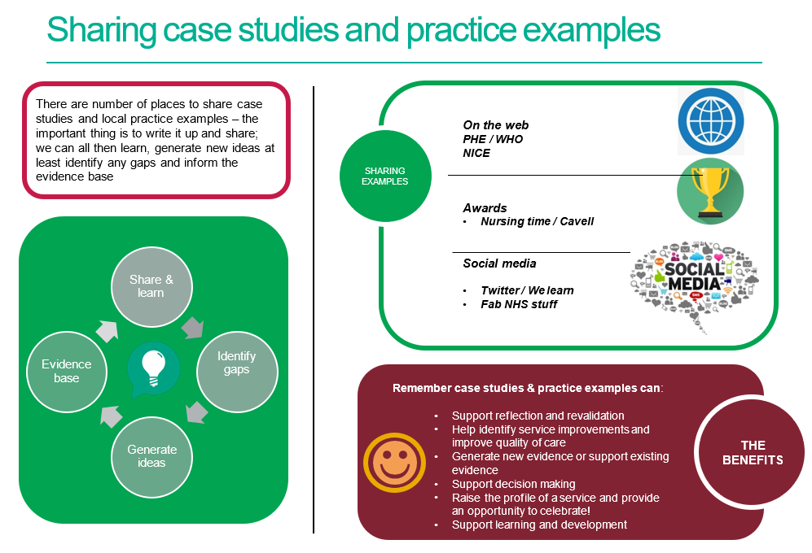

References / further reading

https://www.rcn.org.uk/professional-development/nice-collaboration/nice-case-studies

http://www2.hull.ac.uk/lli/pdf/Case%20Studies.pdf

https://www.brookes.ac.uk/students/upgrade/study-skills/reflective-writing-using-gibbs/

http://www.euro.who.int/en/health-topics/Life-stages/child-and-adolescent- health/publications/2013/improving-the-lives-of-children-and-young-people-case-studies-from- europe.-volume-1.-early-years

http://www.nesta.org.uk/centre-social-action-innovation-fund-evaluations/nesta-standards- evidence

Please complete and return your Case study/ Practice example to:
WHO Collaborating Centre for Public Health Nursing and Midwifery) on: nme.whocc@phe.gov.uk

