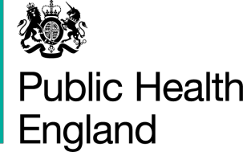

Public Health England

Case Studies and Local Practice Examples Templates
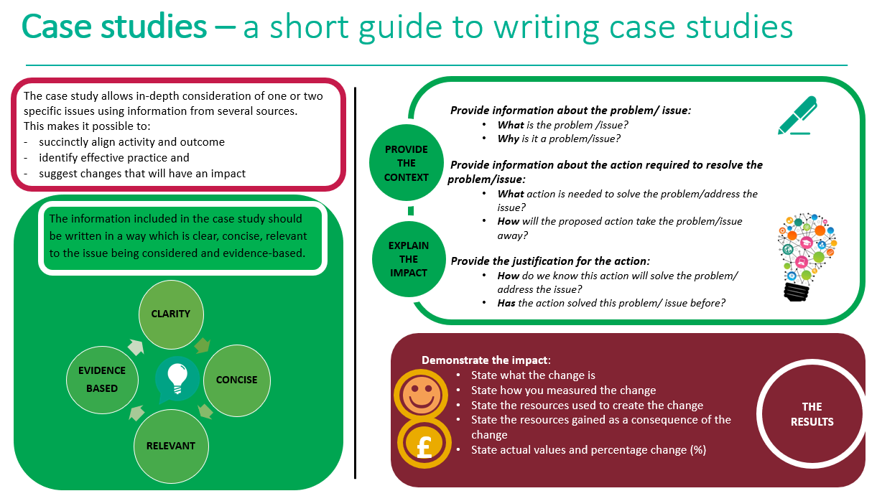

Case study template
Title (Word count 50 max)
Choose a short title which reflects the case study and captures the readers interest
Author: add contact details
Context (Word count 250 Max)
- What was the current situation?
- What is the problem/issue?
- What is the reason for the change?

Solution (Word count 200 Max)
- What is the proposed change?
- How will this change improve the situation?
Action (Word count 300 Max)
- What will be done?
- How will it be done?
- Why will this be done?

Outcome and Impact (Word count 500 Max)
- What is the actual outcome?
- What is the actual difference the change has made?
- Use quantitative (hard), qualitative (soft) and cost (financial) data to describe the change
Lessons Learned and Recommendations (Word count 500 Max)
- What worked well?
- What could be done differently?
- How will the change be sustained over time?
- Use quotations to illustrate the difference the change has made to people
References
- State the research study which illustrates how the chosen action has achieved the preferred outcome
- Use the Harvard referencing system

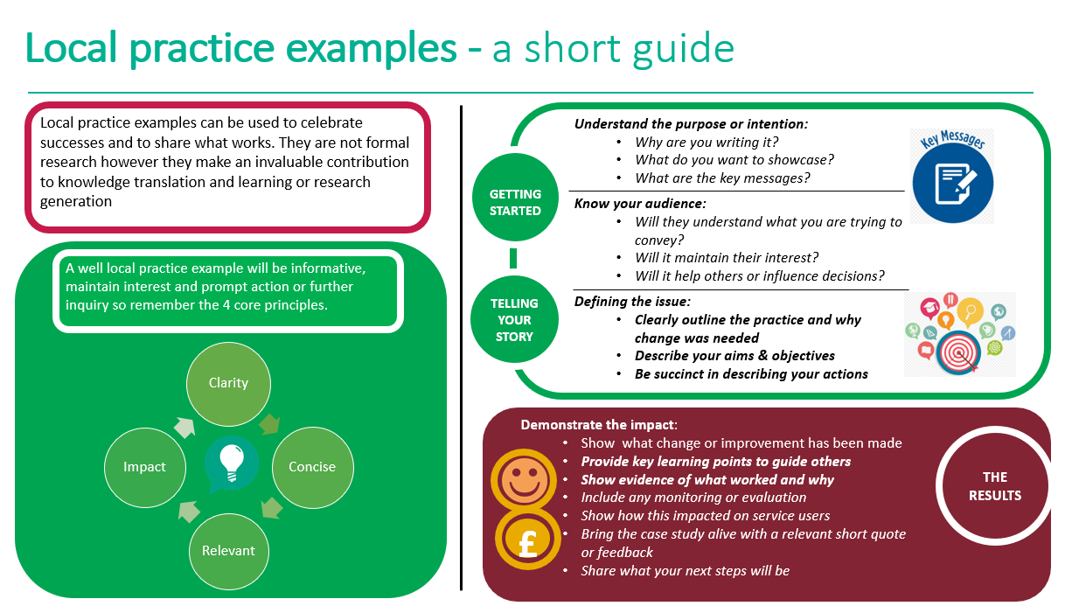
Local practice example template

Title (Word count 65 max)  Include a short descriptive title which reflects the key focus and main benefit  Author: add contact details | Puberty resource guide for parents and carers  Angela Ellins  Health Improvement Practitioner (Advanced),  Public Health Team,  Newcastle City Council  angela.ellins@newcastle.gov.uk
Description (Word count 100 Max)  Include a short focused description of your practice example & the main benefit | The Public Health Team within Newcastle City Council produced a ‘Top Tips’ resource, that includes a range of websites, books and resources, including a Biteables video, to help parents and carers talk about puberty and growing up with their children, whilst schools are closed during the COVID-19 pandemic.  Talking about the onset of puberty with children is important and one upside to being in lockdown is that it gives families time to have these important conversations at a time and pace that is suitable for both parent and child.
Context – what was the aim? (Word count 150 Max)  - Provide a concise overview of your aims and objectives  - Describe the starting point, baseline and include useful data about population or demographics  - Explain how the need arose | Aim  To produce an accessible range of resources to support parents talking to their child about puberty and growing up.  Each year, many primary school children in Newcastle (years 5 and 6) receive a puberty lesson from the school nurse attached to the school. This puberty lesson is one of many ‘Relationships Education’ (RE) lessons delivered within primary education and compliments lessons planned and delivered within the school PSHE curriculum.  Some Newcastle schools were preparing to receive this input within the summer term when schools closed and it was felt that pupils would miss out on this vital education.  Local and national research studies highlight that many children want their parents to talk to them about how their bodies change as they grow up, but parents can find it difficult to initiate these discussions.  The public health team felt that a suitable resource could be developed and sent to all primary and middle schools, to disseminate to parents and carers during the COVID-19 pandemic and resulting school closures.
Method – what did you do? (Word count 200 Max)  Provide clear details of:  - What activity you undertook  - Who was involved and why | We developed a ‘Top Tips’ guide for parents, to generate ideas to help start conversations between parents, carers and children.  These tips included: looking at a range of resources to identify those suitable for your family; using a gingerbread person as a prompt for your child to identify physical and emotional changes during puberty and recommending the use of the correct terminology for body parts.  We identified a range of books and websites for parents and categorized the website links according into those with video clips, those with lesson plans and those suitable for use with children with additional learning needs.  We involved the School Health Team lead for PSHE and added their single point of access telephone number, so parents could contact them for further guidance if required.  Three key communication messages accompanied the resource, which were sent to the communication team within the council for dissemination and publicity. NCC Communications team produced a press release, highlighted the resource via the council Facebook, YouTube and Twitter pages, and a link to the resource was placed on the NCC coronavirus main webpage (under relationship education).  The resource was disseminated to head teachers and features in the Healthy Schools Newsletter and Healthy Schools website.  A Biteables film has since been developed to compliment the original resource and is due to be launched in the next couple of weeks.
Outcomes – what difference did you make? (Word count 200 Max)  - How was this measured?  - Can you show evidence of impact?  - What has changed?  - Was there any user feedback?  - Was this value for money / did you make any savings? | We have plans to collect both quantitative and qualitative data to evaluate the effectiveness of the puberty resources, including a parent’s survey and data on digital communications reach. This will be undertaken following the launch of the Biteables film and at a convenient time for our partners.
Key learning points (Word count 500 Max)  Provide key areas of:  - What are the key learning points and what worked well?  - What things you might do differently  - What future plans do you have to embed this? | What are the key learning points and what worked well?  The Covid-19 pandemic resulted in the public health team working from home, reliant on on-line platforms such as ‘Teams’ as well as emails for communication with internal colleagues and external partners. In normal circumstances the development of a piece of work such as the puberty resource would have brought colleagues together with ‘face to face’ meetings. Although getting together in person has advantages, including the added creativity resulting from colleagues being in the same room and bouncing ideas off each other, lockdown has shown that alternative approaches can work just as effectively and can reduce resource costs, especially with the absence of travelling to and from meetings.  The COVID-19 pandemic has highlighted the need to be flexible and adaptable to the ever-changing circumstances we find ourselves in. At the beginning of this resource development, schools were closed, with no plans to reopen. During the development the situation changed, and some primary schools are now preparing to reopen as early as next week. These changes resulted in the Biteables film resource being adapted to recognize the changing environment.  Due to the launch of other public health resources, the launch of the puberty resource has been delayed, which potentially risks the resource losing its maximum value of engaging parents and carers at this unique time, when many families are engaged with home tuition.  Using the online platform ‘Teams’ to save and share resources worked well, enabled colleagues to comment in a timely way and is an effective way of managing documents.  The puberty resources were low cost to produce, requiring only staff time to write the puberty guide for parents and carers and produce a film using www.biteable.com which can be accessed free of charge.  What things you might do differently  The restrictions of ‘lockdown’ resulted in the cancellation of all face to face CPD training sessions, forums and school visits. Prior to ‘lockdown’ the public health team were planning RSE CPD training with PSHE and Healthy School leads and would have piloted the resources during these sessions, welcoming comment and feedback.  Additional input from the school nursing team would also have been sought, in normal circumstances. Due to the COVID-19 pandemic the school nursing teams focus was mainly concerned with child protection, preventing wider involvement from this key delivery partner.  Challenges and limitations  We acknowledge that many families do not have home access to the internet and / or can afford to buy books to support home education. With city libraries currently closed, this brings further access difficulties to resources that can support RSE education in the home.  An absence of books and resources suitable for BAME communities highlighted a gap in this area of on-line RSE education.  What future plans do you have to embed this?  The puberty resource is one of a range of public health resources developed by the public health team during lockdown. These will be available to be utilized by schools, community settings and families following the COVID-19 pandemic.  The resources, including the Bitables puberty film can be easily adapted to remove the reference of ‘lockdown’ and schools being closed.  Future dissemination could be planned around sexual health week (September) and coincide with the introduction of statutory RSE in England.
References  Include relevant links and references where appropriate | N/A

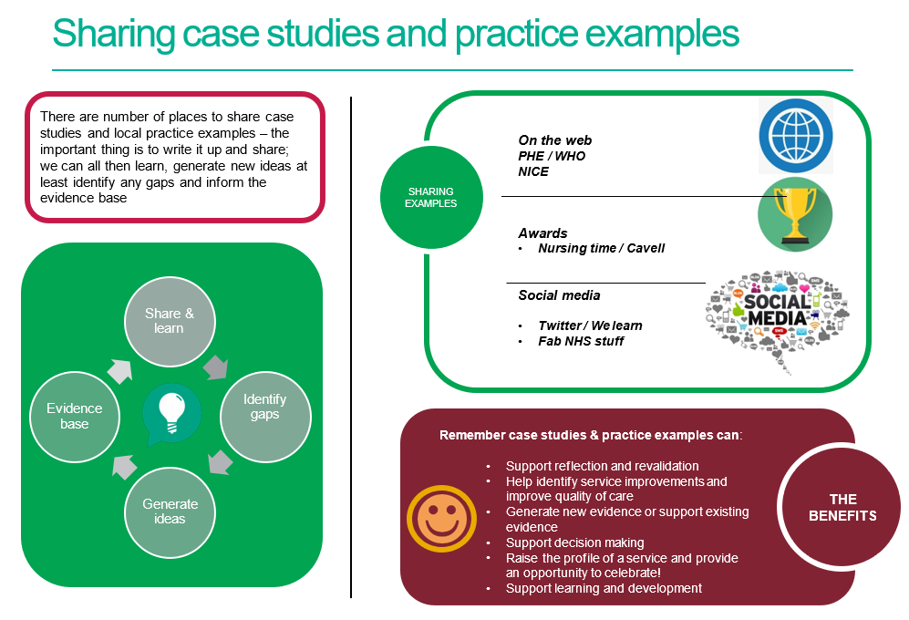

References / further reading

https://www.rcn.org.uk/professional-development/nice-collaboration/nice-case-studies

http://www2.hull.ac.uk/lli/pdf/Case%20Studies.pdf

https://www.brookes.ac.uk/students/upgrade/study-skills/reflective-writing-using-gibbs/

http://www.euro.who.int/en/health-topics/Life-stages/child-and-adolescent- health/publications/2013/improving-the-lives-of-children-and-young-people-case-studies-from- europe.-volume-1.-early-years

http://www.nesta.org.uk/centre-social-action-innovation-fund-evaluations/nesta-standards- evidence

Please complete and return your Case study/ Practice example to:
WHO Collaborating Centre for Public Health Nursing and Midwifery) on: nme.whocc@phe.gov.uk

