Public Health England

Case Studies and Local Practice Examples Templates
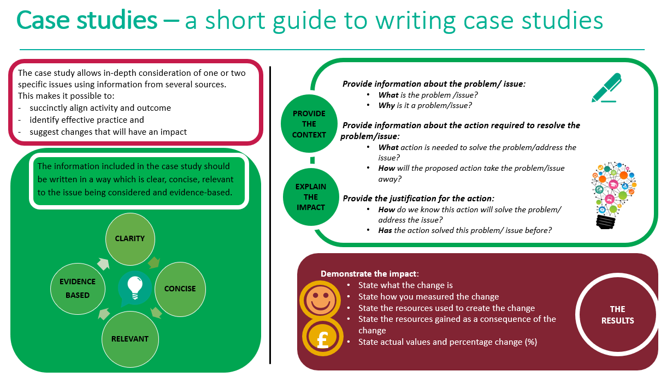

Case study template
Title (Word count 50 max)
Choose a short title which reflects the case study and captures the readers interest
Author: add contact details
Context (Word count 250 Max)
- What was the current situation?
- What is the problem/issue?
- What is the reason for the change?

Solution (Word count 200 Max)
- What is the proposed change?
- How will this change improve the situation?
Action (Word count 300 Max)
- What will be done?
- How will it be done?
- Why will this be done?

Outcome and Impact (Word count 500 Max)
- What is the actual outcome?
- What is the actual difference the change has made?
- Use quantitative (hard), qualitative (soft) and cost (financial) data to describe the change
Lessons Learned and Recommendations (Word count 500 Max)
- What worked well?
- What could be done differently?
- How will the change be sustained over time?
- Use quotations to illustrate the difference the change has made to people
References
- State the research study which illustrates how the chosen action has achieved the preferred outcome
- Use the Harvard referencing system

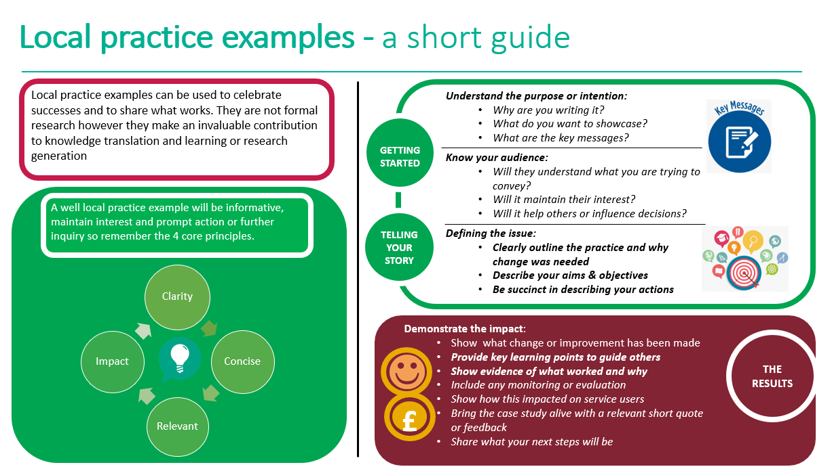
Local practice example template

Title (Word count 65 max)  Include a short descriptive title which reflects the key focus and main benefit  Author: add contact details | Practice Example of School Nurse “Walk and Talk” appointment conducted with a young person to enable the delivery of emotional wellbeing strategies when alternative delivery methods such as video or telephone are not suitable during the Covid 19 pandemic.  Authors:  Eva Trkulja SCPHN School Nurse Eva.Trkulja@nhft.nhs.uk  Debbie Craggs SCPHN School Nurse Deborah.Craggs@nhft.nhs.uk
Description (Word count 100 Max)  Include a short focused description of your practice example & the main benefit | A “Walk and Talk” appointment with a young person is offered as their preferred means to receive evidence based emotional wellbeing intervention within a community setting during the Covid19 pandemic school closure. Whilst telephone or video contacts are offered to ensure safety and prevent transmission of Covid19, there are cases where it is recognised that face to face contact is required and can be delivered safely. The main benefit of this is to allow for early therapeutic intervention and prevent deterioration of emotional wellbeing when alternative methods such as video or telephone are not suitable.
Context – what was the aim? (Word count 150 Max)  - Provide a concise overview of your aims and objectives  - Describe the starting point, baseline and include useful data about population or demographics  - Explain how the need arose | The aim was to meet the needs of the young person, prioritising on and continuing to deliver emotional health and wellbeing support (NHS England and NHS Improvement coronavirus, 2020). Failure to meet the health needs of children and young people potentially stores up problems for the future, so the objective was to ensure timely assessment and early identification of risk factors (Healthy Child Programme, 2009).  In this demographic, there are higher than the national average of young people who are more likely to be admitted to hospital due to self-harm (Northamptonshire County Council, 2019). There are also pockets of deprivation, high numbers of children and young people under child protection plans and strong links to county lines exploitation. Normal support networks are less available at this time, thus increasing concerns for young people’s emotional and mental health.  Following an holistic health assessment of the young person, the need for emotional wellbeing support was identified as low level emotional distress with one previous episode of self-harm and low self-esteem. The options were then discussed with the young person and parents.
Method – what did you do? (Word count 200 Max)  Provide clear details of:  - What activity you undertook  - Who was involved and why | A risk assessment was undertaken prior to the meeting; this included checking that no-one in the household had Covid 19 symptoms, gaining parental consent, agreed time of meeting and conclusion, telephone contact numbers and lone worker policy was applied.  The School Nurse used empathy and communication skills to connect with the young person and gain insight into their worries about school work deadlines and relationships.  The young person was guided to consider early warning signs (EWS) and feelings which are designed to keep them safe. Problem solving skills were utilised – the young person was able to find a solution with guidance and discover that they could start by doing one small piece of work today and then enjoy their weekend. They were encouraged to plan again for the next week and choose another task to complete then.  The School Nurse used the outdoor surroundings to reinforce the benefits of being mindful – building an awareness of our feelings and our physical sensations along with taking time to notice the present can improve our physical and mental well-being, our relationships and our performance at school (Action For Happiness, 2020).
Outcomes – what difference did you make? (Word count 200 Max)  - How was this measured?  - Can you show evidence of impact?  - What has changed?  - Was there any user feedback?  - Was this value for money / did you make any savings? | Following the appointments verbal feedback from the young people and families indicated that the session was valued and helpful. As this is a new initiative and only used with two other young people so far it is too early to identify any long term impact currently and as I Want Great Care has been suspended due to the pandemic as a service we are therefore unable to gather anonymous feedback at the present time. Evidence of the impact can be gathered at the end of the short term intervention using the Short Warwick-Edinburgh Mental Wellbeing Score (Warwick Medical School, 2020) recorded before and after the intervention.  In this instance, the young person stated that they had learned that they don't have to worry about everything all the time and that they can take small steps to complete some work rather than ignore a mounting ever increasing pile. They also gained an increased awareness of their body reactions to worry and learned a mindfulness skill to practice.  As a result of this change the Trust is now developing a protocol and risk assessment using this feedback in order to standardize practice and ensure the intervention is safe for the young people and staff.  There are no identified cost savings at the current time, however, by having the opportunity to offer an early intervention there could be an associated cost saving with reducing difficulties and escalation to specialist services in the future.
Key learning points (Word count 500 Max)  Provide key areas of:  - What are the key learning points and what worked well?  - What things you might do differently  - What future plans do you have to embed this? | The value of face to face contact and the depth of communication through non-verbal expression cannot be underestimated. As professionals working with young people we need to be flexible in the way that we meet their needs and recognise that they value choice in the way they interact with services. Having offered technology based virtual contacts and telephone appointments some young people still prefer to have the face to face contact in person.  The use of outside space brings another dimension to the appointment and for those struggling at home or in school this is a valuable environment to use to engage in a calm manner that we previously may have overlooked and can aid Mindfulness activities and emotional regulation.  Moving forward the use of outside space within schools would provide similar benefits and reduce the risks associated with public spaces.  In the future, the plan is to embed this into wider 0-19 practice through the use of a formal protocol and risk assessment to guide School Nursing staff.  Currently the focus has been on secondary school aged young people but consideration needs to be given to the benefits to primary school children within the school premises and also for Health Visitors to consider when meeting with parents.
References  Include relevant links and references where appropriate | Action For Happiness: Ten Keys to happier Living. 2020. Available at: https://www.actionforhappiness.org/10-keys [accessed 15/06/20]  Director of Public Health Annual Report 2018/19 Northamptonshire County Council. Available at: https://bit.ly/2Y5VDJ2 [accessed 15/06/20]  Healthy Child Programme 5-19. Department of Health. 2009  NHS England and NHS Improvement coronavirus. COVID-19 prioritisation within community health services. 2020 Available at: https://bit.ly/2SUCmY4 [accessed 16/06/20]  Warwick Medical School, 2020. Available at: https://warwick.ac.uk/fac/sci/med/research/platform/wemwbs/using/howto [accessed 15/06/20]

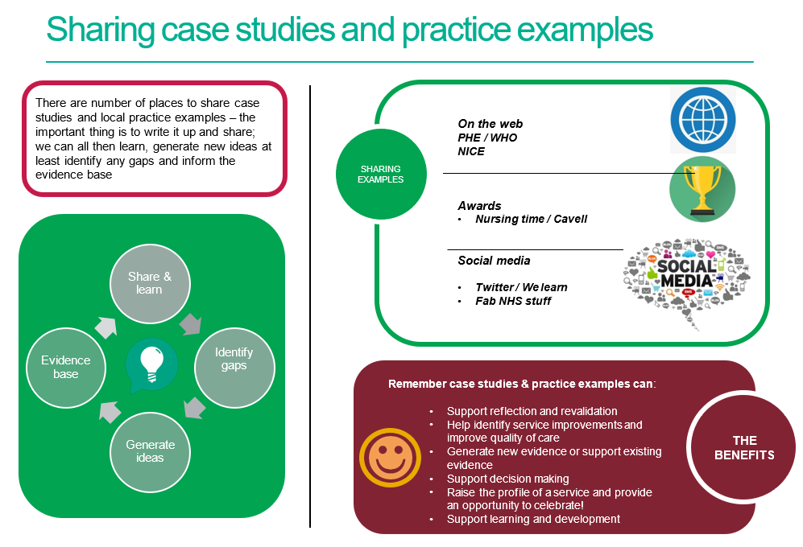

References / further reading

https://www.rcn.org.uk/professional-development/nice-collaboration/nice-case-studies

http://www2.hull.ac.uk/lli/pdf/Case%20Studies.pdf

https://www.brookes.ac.uk/students/upgrade/study-skills/reflective-writing-using-gibbs/

http://www.euro.who.int/en/health-topics/Life-stages/child-and-adolescent- health/publications/2013/improving-the-lives-of-children-and-young-people-case-studies-from- europe.-volume-1.-early-years

http://www.nesta.org.uk/centre-social-action-innovation-fund-evaluations/nesta-standards- evidence

Please complete and return your Case study/ Practice example to:
WHO Collaborating Centre for Public Health Nursing and Midwifery) on: nme.whocc@phe.gov.uk

