Public Health England

Case Studies and Local Practice Examples Templates
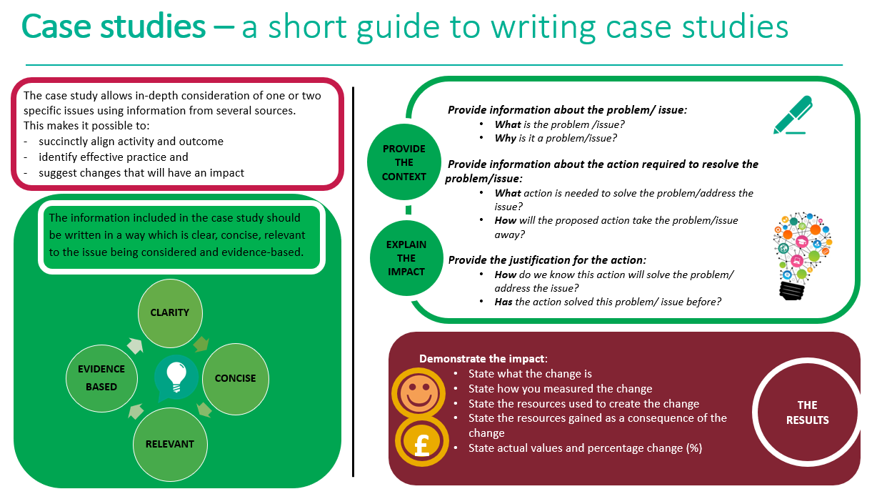

Case study template
Title (Word count 50 max)  Choose a short title which reflects the case study and captures the readers interest  Author: add contact details | Feeding Your Child on a Low Budget: Resources to Support Parents and Carers During Covid 19  Judith MacMorran, Health Improvement Practitioner (Advanced), Public Health Team, Newcastle City Council  Judith.macmorran@newcastle.gov.uk
Context (Word count 250 Max)  - What was the current situation?  - What is the problem/issue?  - What is the reason for the change? | It was recognised that due to the economic impact of the Covid-19 pandemic on communities, that a greater number of parents and carers were likely to suffer from poverty and food insecurity than previously. This included those with children who, due to the closure of schools, were spending more time at home and were not always accessing their Free School Meal (FSM) entitlement, despite this being offered locally. At the same time school breakfast clubs on which many families rely, were no longer operating, meaning that some children were potentially missing two meals per day normally provided at school.  Greater numbers of parents and carers suffered from a drop-in income due to Covid-19 and although some became newly eligible for FSMs, others remained just above the threshold. Nevertheless, more families were struggling financially and required some budgeting support. There was also a concern that some vulnerable families may not have the confidence, skills or knowledge to prepare and cook nutritious food which may impact negatively on child health, for example; through increased obesity rates.  The eventual replacement of the local FSM packed lunch to the national e-voucher scheme, also provided families with a £15 per week per child e-voucher to spend in a supermarket on foods and drinks for their child. This highlighted a need to provide advice and support to parents on how to spend these vouchers effectively.  The Public Health food insecurity team recognised the need to support all families, but particularly those in greatest need, to provide healthy low-cost nutritious food to their children.
Solution (Word count 200 Max)  - What is the proposed change?  - How will this change improve the situation? | It was proposed that as part of the wider Newcastle City Council (NCC) response to Covid-19 food insecurity, a set of resources be produced to support parents and carers of school aged children, to plan and manage their food budget effectively. Whilst of particular use to those suffering financial hardship, and those with FSM, the resources would be of relevance to all parents and carers at any time.  The resources produced needed to be in an accessible format to support parents and carers with poor literacy skills and those who respond more to visual learning. They had to be disseminated widely to parents and carers via Headteachers, school health advisors, community and voluntary sector organisations and community family hubs, and accompanied by city wide communications channels to have greatest reach.
Action (Word count 300 Max)  - What will be done?  - How will it be done?  - Why will this be done? | A hard copy information ‘top tips’ guide for parents can carers on feeding their child on a low budget, and a short film were produced. These can be viewed at  https://www.newcastle.gov.uk/citylife-news/lifestyle/top-tips-help-families-manage-meals-budget  The key focus was on how parents and carers could plan and manage their food budget to cook some healthy, low cost meals for their children. They included reference to food insecurity support available locally and links to useful websites.  The resources were launched publicly on 23 March 2020, with wide dissemination taking place. They were sent to all Head teachers in the city for onward dissemination to parents and carers in whatever way they felt most appropriate. This included via sharing on their own digital media channels, sharing the NCC web and Facebook links and printing off the written information and sending it to all or to some targeted parents and carers. They were also disseminated to many other organisations working with parents and carers.  NCC Communications team undertook extensive media support, with a press release, posting of a clip of the film on the Facebook, YouTube and Twitter pages, and a link to see the whole film and written resource on the news pages of the NCC website. The information was also placed on the NCC coronavirus main webpage
Outcome and Impact (Word count 500 Max)  - What is the actual outcome?  - What is the actual difference the change has made?  - Use quantitative (hard), qualitative (soft) and cost (financial) data to describe the change | Quantitative and qualitative data were collected to evaluate the effectiveness of the resources. The methods used were;  - Survey monkey questionnaire  - Collection of qualitative comments received  - Data on digital communications reach  The survey sent to those who disseminated the resources, was completed by 35 respondents. 86% (n 29) of reported that they had viewed the film and 94% (n33) had read the written information for parents and carers. 83% (n29) of respondents had shared the film with parents and carers and 86% (n30) had shared the written information with them.  The most common way of sharing the resources was via their organisation’s own digital media platforms (Facebook, website, Twitter feed). Of these, their own website and Facebook pages were the most common method of dissemination. Small numbers had shared or liked the NCC Facebook and /or Twitter posts (N5) and only three had shared the NCC weblink which linked to the YouTube channel where the full film could be viewed.  Respondents commented that they shared the resources in other ways including; emailing the links to parents/carers, using the school newsletter, targeting specific parents via direct email, putting a copy into every child’s home learning pack.  Respondents rated the usefulness of the film and written information on a scale of 1-5 (1=Not at all useful – 5=Extremely useful). The overall rating of each resource was 4 (Very useful). Many positive comments were received including;  - “Concise, clear, informative, visual”  - “Keeps families informed and supported”  - “Very good ideas, clear information and guidance”  - “Easy to understand, engaging”  Further qualitative comments were received by email, for example;” I thought the resources were excellent and I know in particular, the written document has been used by a number of our families.” (Head teacher). Local Children and Family Hubs in the city put the written information in the emergency food/activity packs distributed to families and placed links on their Facebook page.  The number of views, hits, likes and shares on digital media of the resources recorded until 22 May 2020 was as follows:  Webpage; Pageviews: 1,082. Average time on page: 3minutes 5seconds  - Referral to webpage;  Social media: 528 (51%)  Direct: 205 (20%)  Referral: 179 (17%)  Organic (search): 105 (10%)  - Youtube video: 246 views  - Facebook;  Date Reach Likes Comments Shares Views  23.3.20 12,956 18 2 39 4.4K  25.4.20 6,215 14 0 7 1.8K  27.4.20 10,740 5 4 7 3.6K  - Twitter  Date Impressions Likes Comments Re-Tweets Views  23.3.20 4,722 7 2 8 698  25.4.20 11,346 36 1 27 2.4k  27.4.20 5,032 9 3 8 831  In addition, articles were placed on local relevant websites and in the staff bulletin. It was also disseminated by Food Active (North West England) and Public Health England North East shared them with Children and Young People leads across the region.
Lessons Learned and Recommendations (Word count 500 Max)  - What worked well?  - What could be done differently?  - How will the change be sustained over time?  - Use quotations to illustrate the difference the change has made to people | Overall the resources were well received. By producing a visual resource as well as a written one, different needs were able to be met to some extent. Whilst the feedback from those receiving the resource was limited and the numbers taking part in the survey were relatively small, the majority of the feedback received was positive. Many families are struggling financially and are in food insecurity; the resources provided a small amount of sustainable support to help budgets stretch further whilst supporting dietary health. They equally remind parents and carers about storage of food and how this can contribute to the sustainability agenda by reducing food waste.  The resources were low cost to produce, requiring only staff time to write the information guide and produce a film using www.biteable.com which can be accessed free of charge. The use of digital media to disseminate messages has high reach and complemented the use of more ‘traditional’ hard copy means.  There was some feedback that the resources needed to be produced in different languages, something which was considered early in the planning phase. It was agreed that due to the high number of languages spoken and the limited technical function of the ‘biteable’ film programme used, it would not be possible to produce multiple films in different languages for different communities. Instead a different solution was sought. Instead, it was agreed that a need for resources for BAME communities on feeding the family when on a low budget should be identified, through discussion with networks working with BAME communities. If a need was identified by the communities, then they were encouraged to film themselves in their first language, cooking low cost meals using familiar ingredients, to share within established local networks. This method had already been used with other resources pertaining to Covid-19.  Information was also included in the written resource about ‘linguacuisine’, an app developed by Newcastle University which provides a huge variety of recipes, accompanied by videos demonstrating the recipes with commentary in different languages. It is designed to help those using recipes, including children to ‘learn a language’ whilst they cook and is already used in Newcastle schools. A link was established with Newcastle University’s Linguacuisine lead, who posted videos of five of the low-cost meal suggestions given in the NCC written information. This was publicised locally. An added benefit of the app is that it enables people to upload their own recipes and videos and encourages family cooking.  Beyond the Covid-19 pandemic, the life of the resources can be maintained by updating them, as required and removing reference to Covid-19 in the future. There is therefore, potential to re-launch them again in a timely manner to support work on tackling poverty and supporting family dietary health, or re-modelling them to focus on food wastage prevention within the context of the climate change agenda.  The project has demonstrated that the use of visual media backed up with written content is a helpful public health communications tool. It is recommended that such methodology be applied to other key public health issues.
References  - State the research study which illustrates how the chosen action has achieved the preferred outcome  - Use the Harvard referencing system | N/A

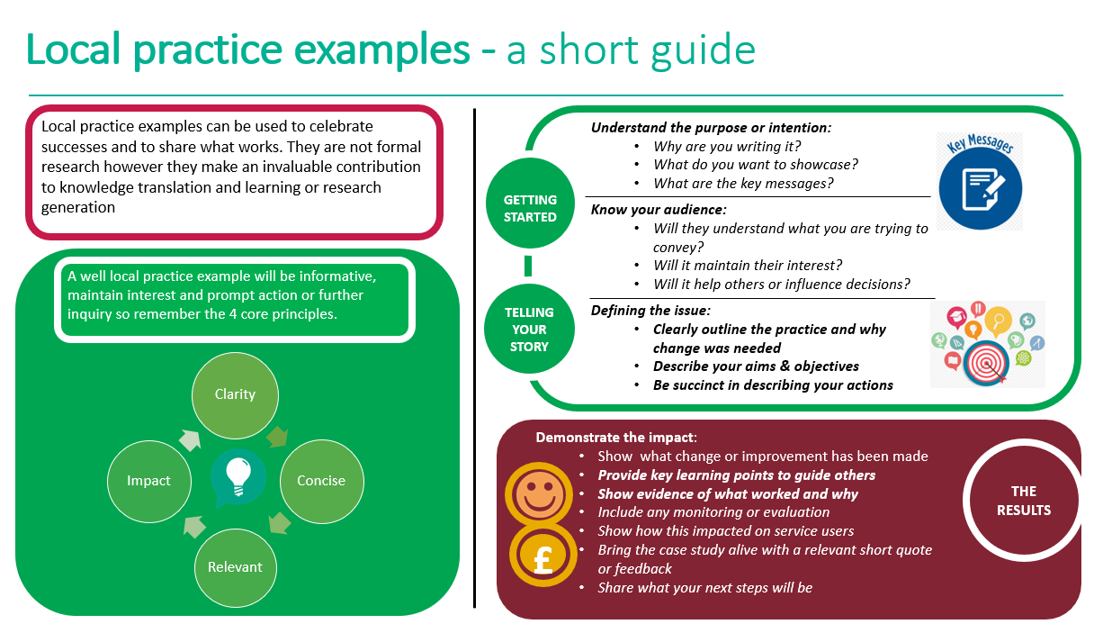
Local practice example template

Title (Word count 65 max)
Include a short descriptive title which reflects the key focus and main benefit
Author: add contact details

Description (Word count 100 Max)
Include a short focused description of your practice example & the main benefit

Context – what was the aim? (Word count 150 Max)
- Provide a concise overview of your aims and objectives
- Describe the starting point, baseline and include useful data about population or demographics
- Explain how the need arose
Method – what did you do? (Word count 200 Max)
Provide clear details of:
- What activity you undertook
- Who was involved and why

Outcomes – what difference did you make? (Word count 200 Max)
- How was this measured?
- Can you show evidence of impact?
- What has changed?
- Was there any user feedback?
- Was this value for money / did you make any savings?
Key learning points (Word count 500 Max)

Provide key areas of:
- What are the key learning points and what worked well?
- What things you might do differently
- What future plans do you have to embed this?
References
Include relevant links and references where appropriate

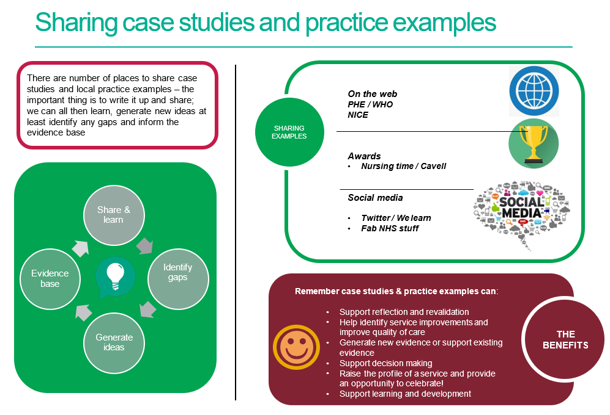

References / further reading

https://www.rcn.org.uk/professional-development/nice-collaboration/nice-case-studies

http://www2.hull.ac.uk/lli/pdf/Case%20Studies.pdf

https://www.brookes.ac.uk/students/upgrade/study-skills/reflective-writing-using-gibbs/

http://www.euro.who.int/en/health-topics/Life-stages/child-and-adolescent- health/publications/2013/improving-the-lives-of-children-and-young-people-case-studies-from- europe.-volume-1.-early-years

http://www.nesta.org.uk/centre-social-action-innovation-fund-evaluations/nesta-standards- evidence

Please complete and return your Case study/ Practice example to:
WHO Collaborating Centre for Public Health Nursing and Midwifery) on: nme.whocc@phe.gov.uk

