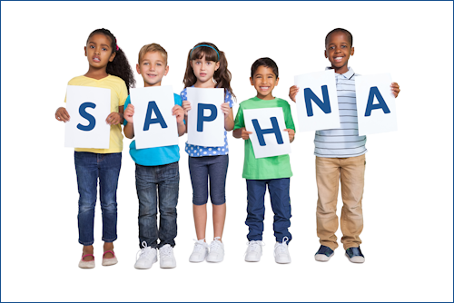
Newsletter Spring 2020
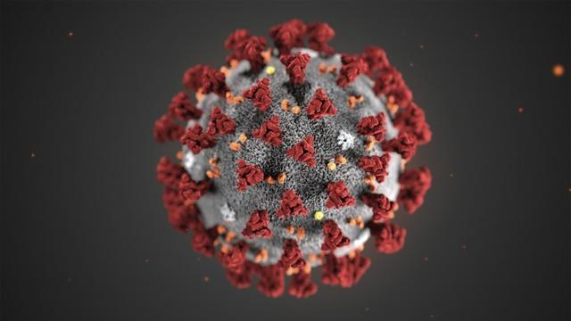
This Photo by Unknown Author is licensed under CC BY-NC-ND
Coronavirus
We find ourselves in the most extraordinary of times as we fight the global pandemic that is Coronavirus.

For many of us on both a personal and professional level, this is causing much flux, anxiety and rapid change and challenge. During these times we need to ensure that, as a community, we play our part in supporting one another as a workforce and, as a Nursing profession. We've pulled together some of the main resources which may be of use to you but do use the links below alongside our activity on Twitter @SAPHNASharonOBE @SAPHNATeam

- For the latest news and updates from NHS England and NHS Improvement please visit: https://www.england.nhs.uk/coronavirus/

- For health information and advice please visit: https://111.nhs.uk/covid-19

- To learn about the government response please visit: https://gov.uk/coronavirus

The Coronavirus and your wellbeing
https://www.mind.org.uk/information-support/coronavirus-and-your-wellbeing/

COVID Community Services prioritisation protocol
https://www.england.nhs.uk/coronavirus/publication/covid-19-prioritisation-within-community-health-services-with-annex_19-march-2020/

Coronavirus (COVID-19): guidance on vulnerable children and young people
https://www.gov.uk/government/publications/coronavirus-covid-19-guidance-on-vulnerable-children-and-young-people/coronavirus-covid-19-guidance-on-vulnerable-children-and-young-people

COVID guidance for schools and colleges maintaining provision
https://www.gov.uk/government/publications/coronavirus-covid-19-maintaining-educational-provision/guidance-for-schools-colleges-and-local-authorities-on-maintaining-educational-provision

Coronavirus e-learning for Healthcare
https://www.e-lfh.org.uk/programmes/coronavirus/

World Health Organisation COVID Training
https://openwho.org/channels/covid-19

Coronavirus game
https://games.focusgames.co.uk/coronavirus/game/

FREE download book to help explain to children: Dave the dog is worried about Coronavirus
https://nursedottybooks.com/dave-the-dog-is-worried-about-coronavirus-2/

Coronavirus: top 5 handwashing songs https://www.tes.com/news/coronavirus-top-5-handwashing-songs-children

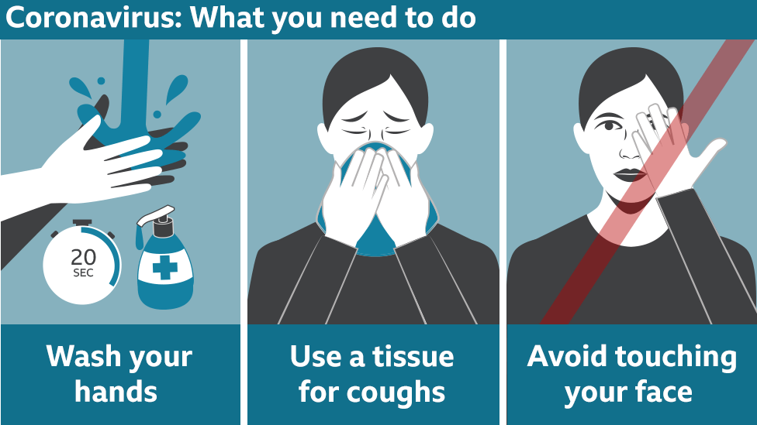

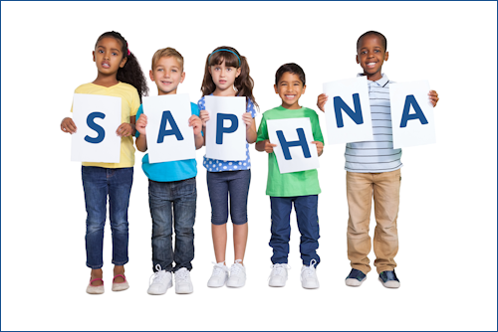

SAPHNA New Website Launch

Headline news…SAPHNA LAUNCH NEW WEBSITE!

SAPHNA are delighted to be launching their brand new website
www.saphna.co.uk

I am sure you will agree this provides you, our stakeholders and partners with relevant up-to-date information, best practice, resources, training and much more including a range of opportunities for membership and free, discounted and unique benefits including 40% off the British Journal of Child Health (formally BJSN). Sharon White OBE, CEO SAPHNA @SAPHNASharonOBE

Disappointingly, due to COVID19, our annual conference has had to be postponed.
We now hope to run this in November so do please keep an eye on our website for updates. www.saphna.co

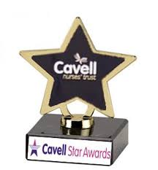
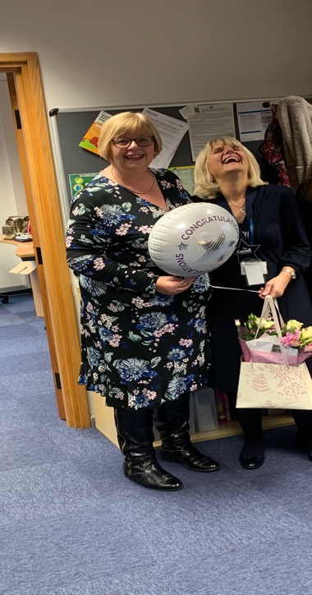
Our very own Maggie -received the ‘Cavell Star Award’ for her outstanding contributions to School Nursing

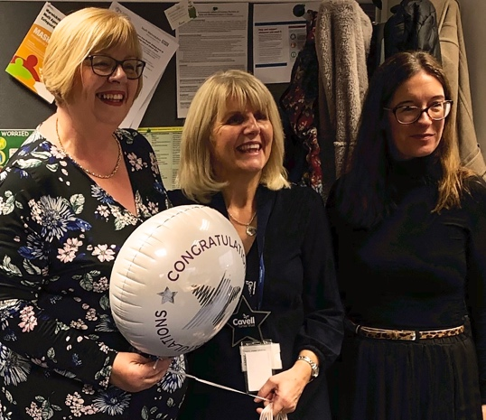
Cavell Star Awards are given to nurses, midwives, nursing associates and healthcare assistants who have shown an exceptional level of care. The nomination was made by Sharon White, CEO of SAPHNA: the School and Public Health Nurses Association.
Sharon and Maggie worked together to implement the school nursing model for the Warwickshire Health and Wellbeing Service when Compass first took on the contract in November 2015. This included bringing the service in-line with modern practices and requirements; for example, bringing in an electronic version of the Health Needs Assessment, using technology to identify different triggers for various forms of support.
As with most organisational changes, this transition presented many challenges, but Sharon recalls how Maggie got colleagues and stakeholders on board and ensured the promised service was delivered:
“Maggie was brilliant at getting people to buy in — which was very difficult at the time. She’s strong, articulate, and highly intelligent, but she’s also empathetic and diplomatic, which always gets the best from people. Her compassionate leadership style is one of the key reasons I nominated her for this award, as it has really made a difference over the years.”
Over the past four years, Maggie has continued to gather evidence to demonstrate the service’s positive outcomes and make adaptations where required, which has been crucial to its success. Compass has recently been recommissioned once again and continues to deliver the Warwickshire Health and Wellbeing Service with Maggie’s guidance. https://www.warwickshire.gov.uk/schoolhealthandwellbeing
Alongside her role at Compass, Maggie is also the Executive Lead Officer at SAPHNA, working with Sharon to make sure school nursing services across the UK meet the needs of children, young people and families today. She has been instrumental in initiatives such as ChatHealth, which enables young people to get confidential health advice via text message.
“She’s loved and respected both locally and Nationally, “said Sharon. “She’s a change agent – she’s been key in the modernisation of school nursing.” said Sharon. We are honoured to have her as SAPHNA’s Exec Lead Officer.
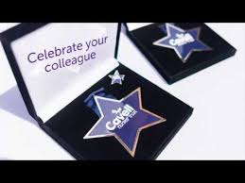
Maggie said: “I’m overwhelmed to receive this award, particularly because of the background of the Cavell Star Awards which roots back to nurses who made phenomenal contributions in the early days of nursing that changed lives and brought us to where we are today. I don’t think I should get all the credit though – it only works because we all work together and put young people at the heart of everything we do and every decision we make. I feel really proud we are able to do that, so thank you.
A New Decade Poem from one of our very talented SAPHNA committee…
If anyone has anything on a lighter note they would like to share then please contact the SAPHNA team info@saphna.co

@SAPHNATeam

A new decade is upon us time to reflect, examine explore
Where we want to go, where we are now what has gone before
In 2020 we celebrate Year of the Nurse & Midwife
We remember the words “poetry and imagination bring life”
Nursing cradle to grave and in between
Work done but not always valued or seen
School Nurses with a vital role to play
Supporting school aged children in their unique way
So take a moment and celebrate the new decade ahead
Embrace the SCPHN role and remember what Florence once said
“Live life while you have it Life is a splendid gift - there is nothing small about it”
Words from history that never date
Words that have value and always resonate

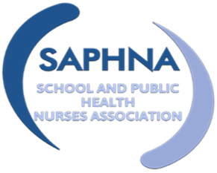
All Our Health…and inequalities- by Lisa Webster
I started my Nursing career as a Learning Disability Nurse 20 years ago. I loved my job and I felt honored to work with and support such wonderful people. However, maybe I was naïve, but I was also saddened how people with learning disabilities were discriminated against in many areas but especially in healthcare. Thankfully this is improving for people with learning disabilities now with the help of legislation and more general awareness, but inequalities still exist, which I have since realised exist for many people in society.
After 10 years as a Learning Disability Nurse I moved into School Nursing where I was equally troubled (and naïve) at the inequalities children and young people face. Deprivation was on my doorstep and I hadn’t noticed. I had the opportunity to complete the Specialist Community Public Health Nursing Degree which I loved but highlighted to me more than ever the injustice for children, young people and families.
School Nurses are in such a privileged position to try and help reduce inequalities and to promote health, it would just help if there were more of us!
Not to be disheartened, as a School Nurse we often underestimate the positive changes we actually do make, which are many. A highlight for me as a School Nurse was always the ‘drop ins’. Being able to listen and support young people was such a privilege. Young people trust Nurses and talk openly- this cannot be underestimated- just by listening and giving a young person time can make a huge difference; which is exactly why School Nursing is an essential service.
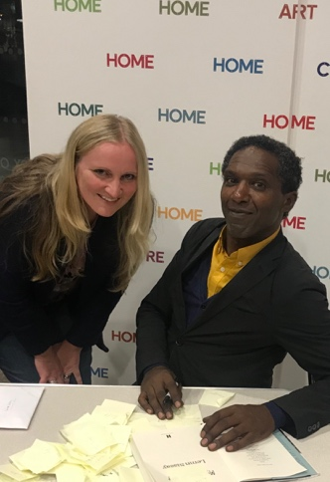
Not only do we support young people with emotional health, we immunise, we promote health, we teach health…in fact this sounds familiar… School Nurses happen to be the very essence of ‘All Our Health’ prevent illness, protect health and promote wellbeing…if you don’t know this guidance here is the link… https://www.gov.uk/government/publications/all-our-health-about-the-framework/all-our-health-about-the-framework
As a School Nurse a safeguarding caseload unfortunately can be overwhelming, it was for me. I was naively thankful when some of my child protection children became ‘looked after’ as I thought at least they are safe. Now as a Looked After Children’s Nurse I realise a lot of these young people are not ‘looked after’ all and yet again I am face to face with inequalities (a theme that has followed me throughout my career).
Thankfully there are some amazing foster carers out there doing an amazing job and that is so positive for many of our young people, but there are also a lot of not so positive placements and residential homes that will not be a positive experience at all. Children and young people in care have already been through so much in their short lives, neglect, bereavement, abuse…we need to love and nurture these children and young people. School Nurses are often one of the few consistencies in a looked after child’s life…what a privilege!
Finally, Lemn Sissay is a poet and author of the book ‘My name is why’. It is an insightful journey into the life of a young boy in care, Lemn himself. I will leave you with some of his amazing poetry…for School Nurses everywhere... Me and Lemn!
Making a Difference (a poem to be read aloud)

We are shaking and waking and breaking indifference
We are quaking and taking and making a difference
We are working observing recording researching
Wherein we’re conferring subverting referring
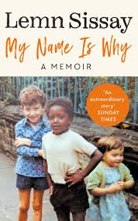
We’re counting the minutes the moments the loss
Redressing the balance addressing the cost
We are citing and fighting it’s all in the writing
The spark is igniting in dark we are lightening
We are breaking the brackets the fact is the planet’s
In rackets and rackets of rackets in brackets
The systems the victims the damning the scamming
The biased predicting the beating and banning
The skills we exchange the breaking of chains
The actions sustained the makers of change
To relentless censors the damned and defenceless
Our words are the action the louder reaction
When no one is listening we hear
When heads turn away we volunteer
We work we stand tall we rise up to be counted
We climb mountains
We are shaking and waking and breaking indifference
We are quaking and taking and making a difference

https://www.manchester.ac.uk/discover/magazine/features/making-a-difference/

Further reading and resources:

2020: Year of the Nurse. The World Health Organization (WHO) has designated 2020 as the “Year of the Nurse and Midwife”, in honour of the 200thbirth anniversary of Florence Nightingale.
https://www.youtube.com/watch?v=8pNeDD5SmgI
To support the WHO Year of the Nurse & Midwife, The Lancet will dedicate a special issue in 2020 to the theme of Nursing, covering #nursing practices around the world
Submit hubs.ly/H0mrFXZ0
#SupportNursesAndMidwives #NursingNow #Nursing2020 #Midwives2020 pic.twitter.com/Oqspl37oB8
New NCMP guidance
https://www.gov.uk/government/publications/national-child-measurement-programme-conversation-framework
FREE E-Learning RSHE by Brook
https://learn.brook.org.uk
FREE BBC PSHE/RSHE Resources
https://www.dosreforschools.com/
https://www.bbc.co.uk/teach/ks1-pshe/zfyskmn
https://www.bbc.co.uk/teach/ks2-pshe/zbrg7nb
https://www.bbc.co.uk/teach/ks3-pshe-modern-studies/zdt3jhv
https://www.bbc.co.uk/teach/gcse-national-5-pshe-modern-studies/zfwtrj6
Wellbeing by Dr Pooky
https://www.youtube.com/watch?v=DH90o3QnPik
‘Your teeth you're in control' for dentally anxious children

https://www.sheffield.ac.uk/dentalschool/research/person-centred-population/child-dental-anxiety/resources

ChatHealth Survey Results
School nurses who use the ChatHealth messaging platform were invited to take part in an annual survey in November 2019. There were over 250 responses from over 70 services, including school nurses, health visitors, sexual health and mental health workers. The survey highlighted that ChatHealth is helping to connect health teams with service users via the well-evidenced messaging platform. Respondents from services that have recently implemented ChatHealth all said their organisation’s outcomes have been met. The majority said they are increasing reach and access for service users. School nurses also commented that it is helping to improve their visibility in schools.
Feedback suggests that awareness of ChatHealth varies; however, three quarters of respondents think service users know about ChatHealth and almost all said they often or always promote it, usually in 1:1’s, business cards, posters and in school assemblies. The NHS-based project team were consistently highly-rated for their support in helping healthcare teams to set-up and run a safe and secure messaging service. The survey results will be used to help to steer the direction of ChatHealth’s future developments, such as an improved practitioner portal and instant messaging app. Thank you to those who took the time to complete the survey.
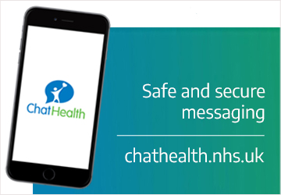
Have your say!

Dr Sue Sherman from Keele University invites you to undertake her survey re universal HPV vaccination
Survey exploring vaccine delivery experiences:
We are interested in exploring how the change to the HPV vaccination programme has impacted on schools, school nurses and immunisation teams, so that we can recommend changes to information for schools, parents and/or children as necessary.
https://keelepsych.co1.qualtrics.com/jfe/form/SV_e4DGlI6TAInzRf7

Optimising obesity communication in primary schools’ study

We’re currently looking for school nurses to take part in our study at the University of Liverpool. The aim of the study is to develop an online tool to enhance obesity communication within primary schools, so we’re looking to identify the current practice around obesity conversation happening in schools across the UK through interviewing staff about these encounters.
We've already interviewed teachers as part of this study, who have highlighted the importance of school nurses and associated roles in managing these situations, so it would be really great to include you in our research if possible. At this point, we're looking for staff to take part in a one to one interview (face-to-face or by phone), and following this, there would be opportunity to take part in the next phase of the research to receive free training, and provide feedback on this.

We would really appreciate your time taking part in this study. To discuss this, and for further information, please contact:
nia.coupe@liverpool.ac.uk

The Last Summer in Soho – written by SAPHNA’s very own Jessica Streeting.

This fascinating, funny and often very moving novel transports us into the life of Sylvie, a community school nurse working in contemporary Soho, London. It’s the summer term and Sylvie is working with her stretched but resourceful team as they strive to serve these diverse children and families who live and work in this extraordinary area of London.
The story offers an authentic and rare insight into the lives of London children today and illustrates the enormous importance of School Nurses.
And, of course, true to @JessStreeting, all proceeds from sales are to be donated to children’s charities

https://www.amazon.co.uk/Last-Summer-Soho-Jessica-Streeting/dp/1093109661/ref=tmm_pap_swatch_0?_encoding=UTF8&qid=&sr=

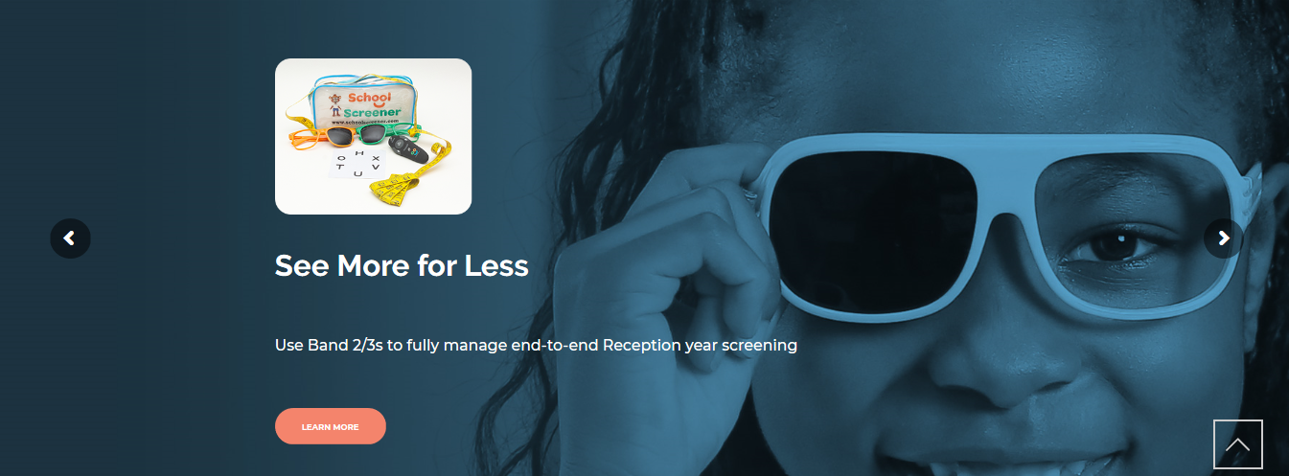

SchoolScreener ® is university-developed software to manage child health data and screening. It's used by Public Health England Providers with over 800,000 children.

Developed in the UK, SchoolScreener ® is designed for school nurses, and skill mix team members including Band 2/3/4s to use. It's proven at scale, it's low cost and it's quick. Implementation and support are tailored to your locality needs. To learn more visit:
https://uk.schoolscreener.com/

